Data Lake

DemoStore

eCommerce version



Index

Ingestion, Processing and Query Data 3

Deploy Solution and Demo 4

Deploy Ingestion and Processing template 5

Check completion of Cloudformation 5

Amazon Kinesis exploration 7

Start Kinesis analytics applications 7

Explore the SQL code in Kinesis Analytics 8

Check the Streaming data sample 9

Explore to the Destination Tab to Kinesis Firehose 10

Verify Amazon S3 console and what is in the bucket 11

Check CloudWatch Dashboard 12

Configurate Kibana 14

Open Management to create an Index 14

Import a Dashboard for Ecommerce transactions 16

Access the Dashboard for Ecommerce transactions 18

Crawler the S3 to pick table definition on Glue 21

Query Data in Amazon Athena 22

You can Adjust Column names on Glue for aggregated Data – Skip this Step 26

Query aggregated data table in Amazon Athena 27

Go to Athena to see the database you have created and preview the tables 28

Visualize Data with Amazon Quicksight 29

Setup permissions to access Athena and S3 from Quicksight 30

Create a Data Source in Amazon Quicksight 31

(OPTIONAL) Tranforming Data – Amazon Glue 36

Create a Tranforming Job in Glue 36

Crawler the S3 to pick table the new table definition on Glue 39

Go to Athena to query the Optimized Table you created 40

# Ingestion, Processing and Query Data





Quicksight

Amazon Glue

To Simulate a real world ingestion we have created a Cloudformation to ingest data to be processed and analyzed.

The process start with a Lambda function that generates random payloads to a Kinesis Streams.

The Kinesis Streams is consumed by 3 different consumers, Kinesis Firehose, Kinesis Data Analytics and a Lambda Function, so for each payload we have 3 destinations.

The Kinesis Data Analytics plays a real time aggregation and/or analysis of the streaming, Kinesis Firehose put exact the raw data into an S3 bucket to be analyzed latter.

Elastic Search is ingested by a Lambda Function and give us a realtime visualization with Kibana.

# Deploy Solution and Demo

**Make sure you are in N.Virginia Region:**

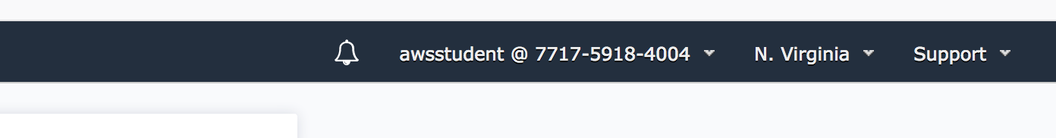

You can Change region if it’s not N.Virginia.

## Deploy Ingestion and Processing template

Use this link if you want to Deploy the Template. **Don’t click in this first link if you have launched it already from the AwsDemostore console:**

<https://console.aws.amazon.com/cloudformation/home?region=us-east-1#/stacks/new?&templateURL=https:%2F%2Fs3.amazonaws.com%2Fawsdemostorecdf-useast1%2Finitial-conf-template%2Fecommerce.template>

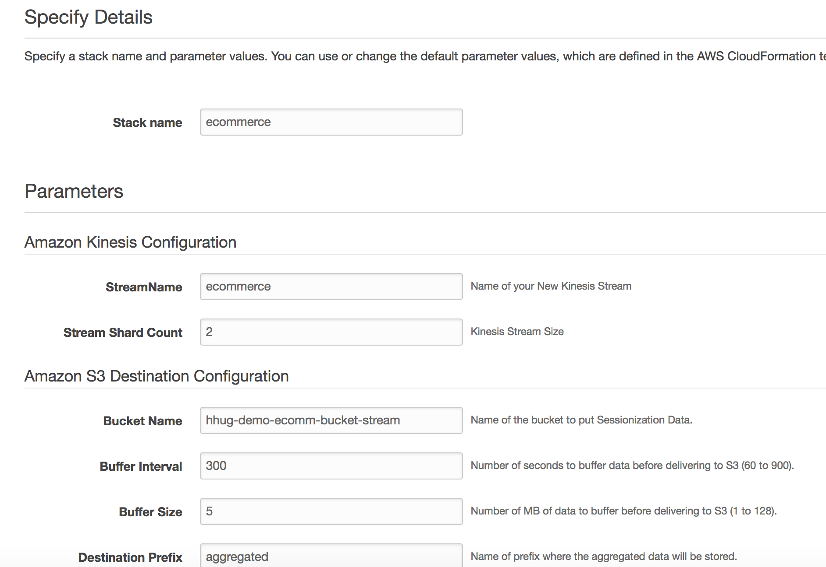

**Now you can check the deployment, and play around.**

### Check completion of Cloudformation

Go to Cloudformation console:

[https://console.aws.amazon.com/cloudformation/home?region=us-east-1#/stacks](https://console.aws.amazon.com/cloudformation/home?region=us-east-1#/stacks?filter=active)

Click on ecommerce template to see the evolution:

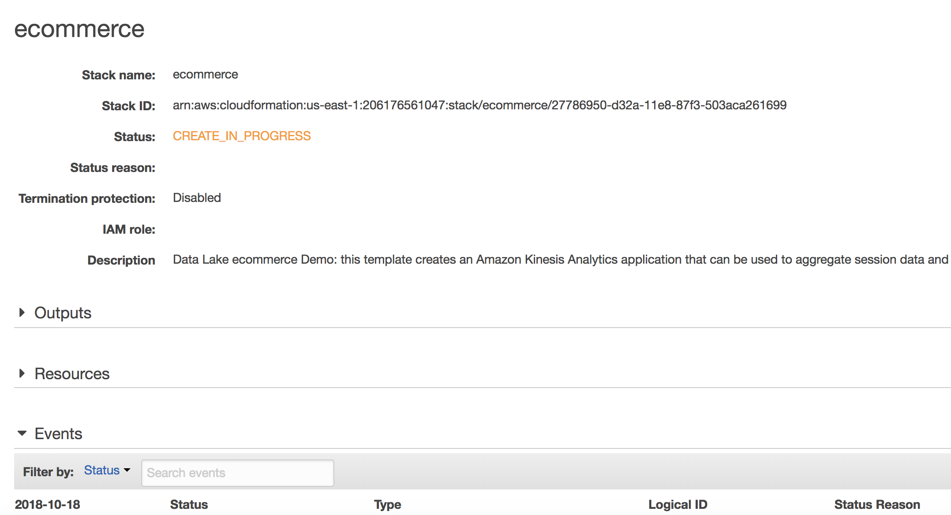

Wait until it appears like that, it will take aprox. 14 minutes to complete:

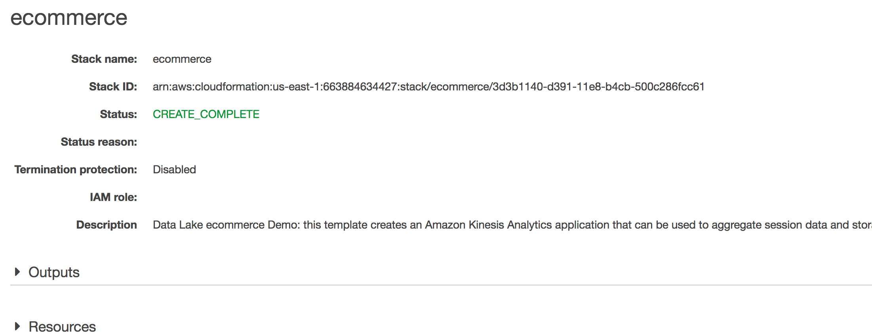

Explore the resources created:

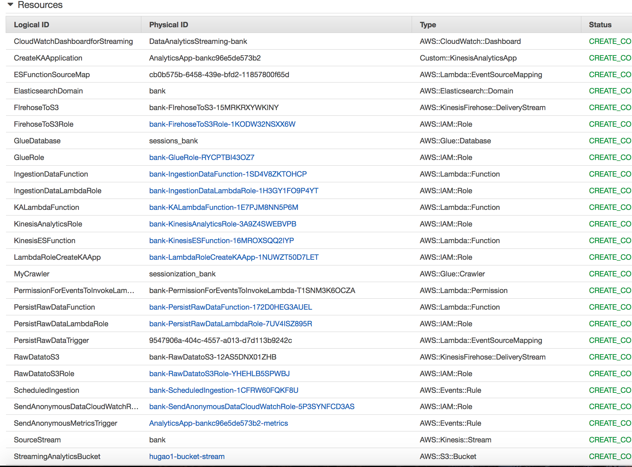

### Amazon Kinesis exploration

Go to Kinesis console:

<https://console.aws.amazon.com/kinesis/home?region=us-east-1#/dashboard>

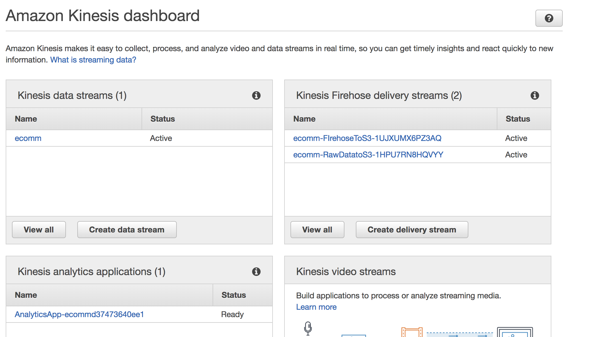

Explore Kinesis data streams and. Kinesis Firehose.

### Start Kinesis analytics applications

<https://console.aws.amazon.com/kinesisanalytics/home?region=us-east-1#/>

Select and open Application Details

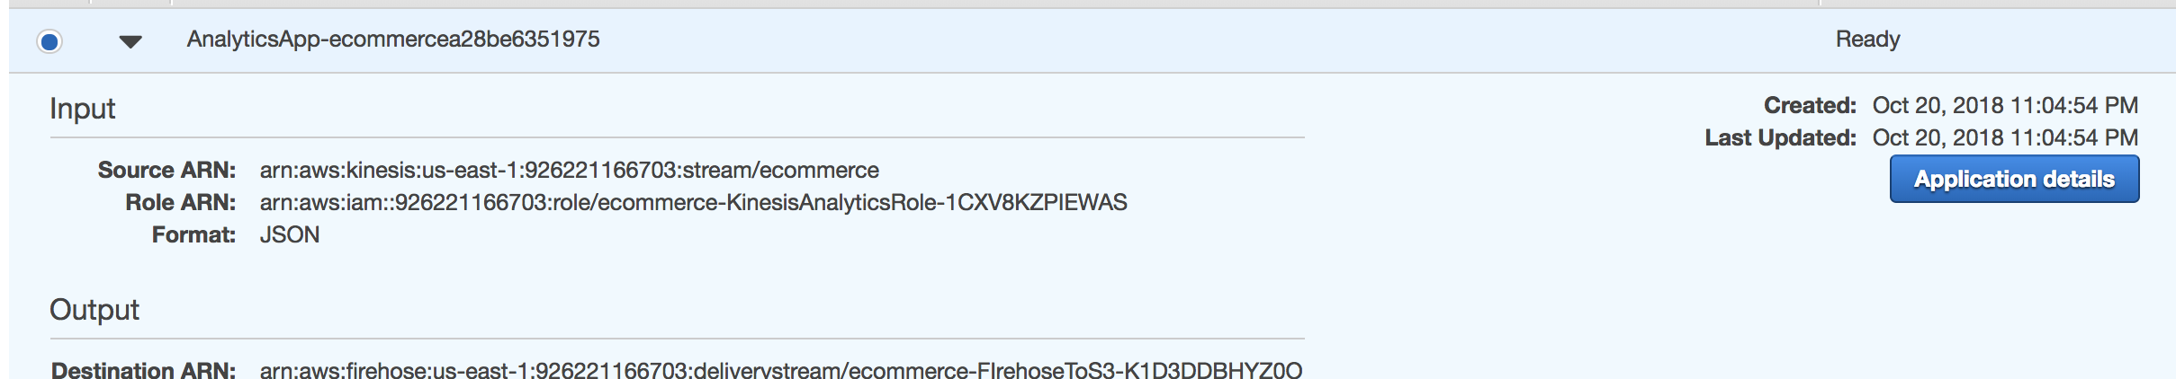

Open the **Application details** and go to “**Go to SQL editor**” button

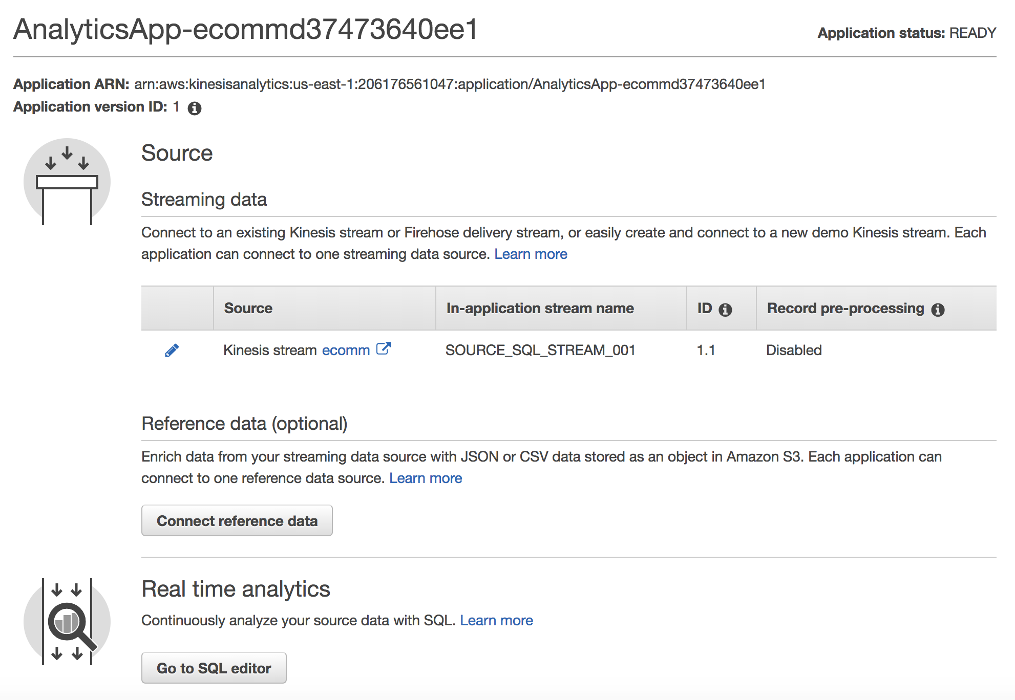

Click Go to SQL editor and Start the application, click “**Yes, start application**”

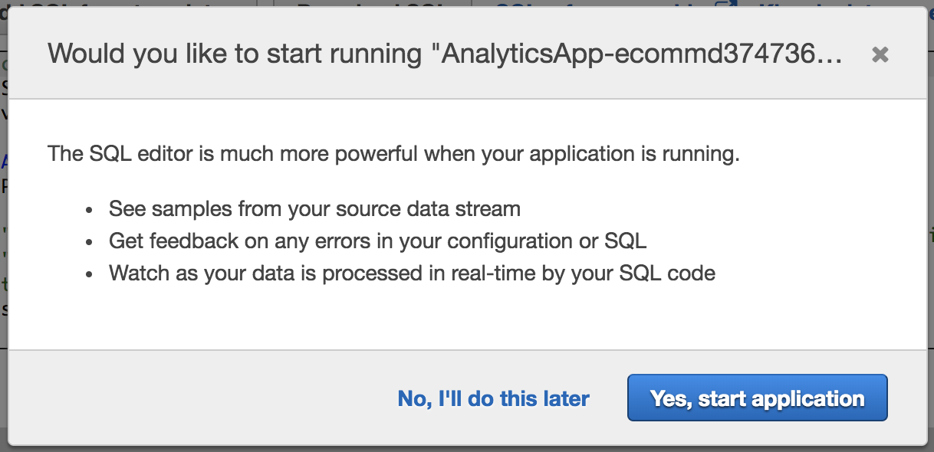

### Explore the SQL code in Kinesis Analytics

Explore the SQL code :

For aggregate metrics for every Customer ID (custid), with the function Stagger Window we can group events for a unique session for a User / Device navigation:

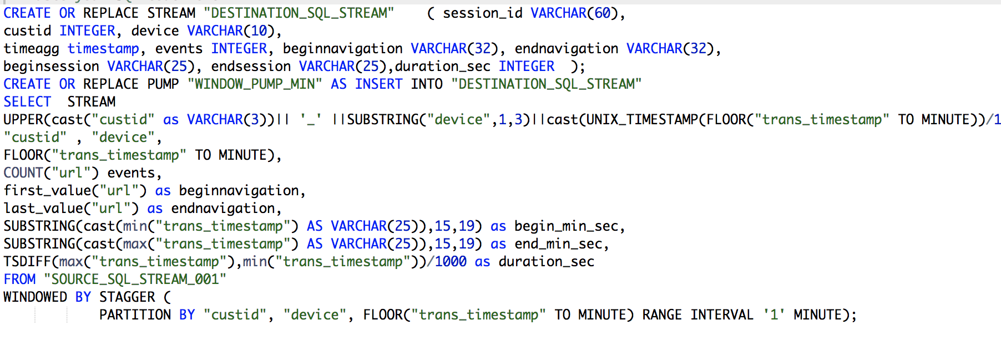

For each session calculated by Stagger Window, with the limit in this case of “1” MINUTE, the code picks the navigations beginning and ending, in terms o URL navigation and Time navigation. Also it creates a Session_ID concatenating CustID + 1-3 substring of Device + Timestamp without miliseconds.

### Check the Streaming data sample

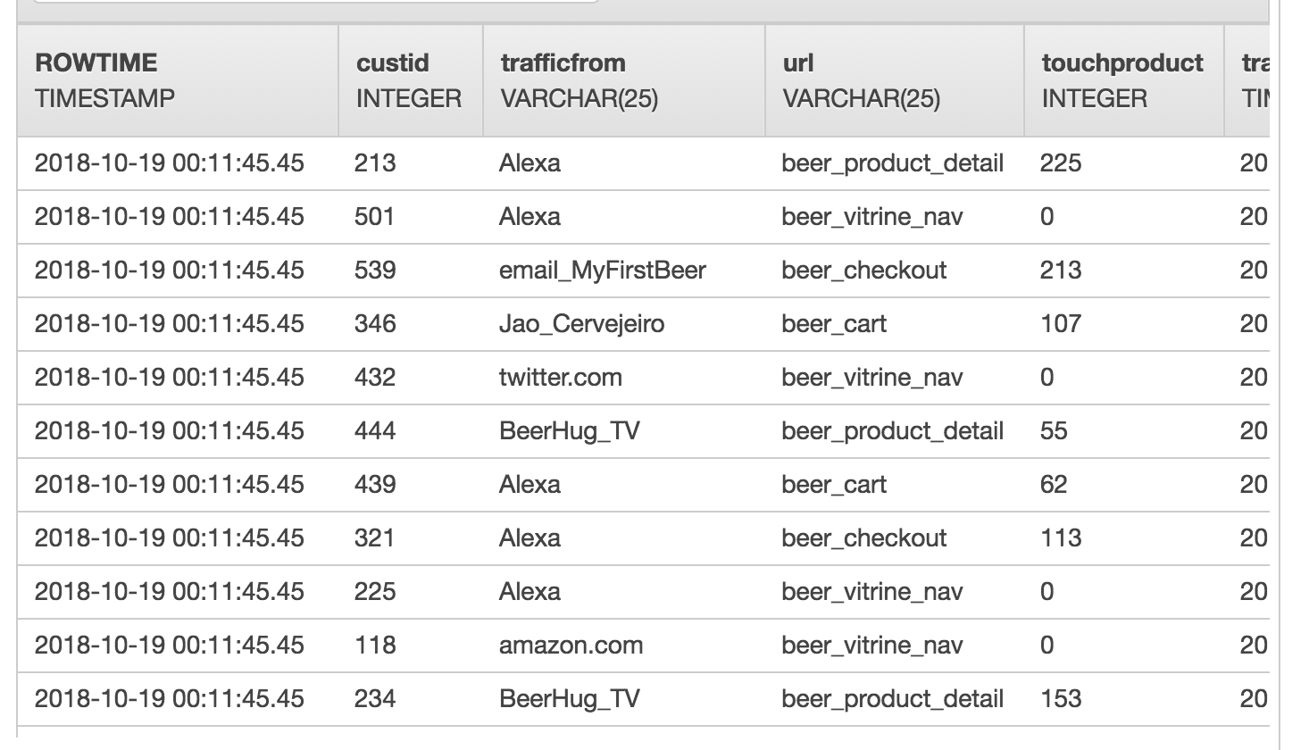

Navigate in the sample :

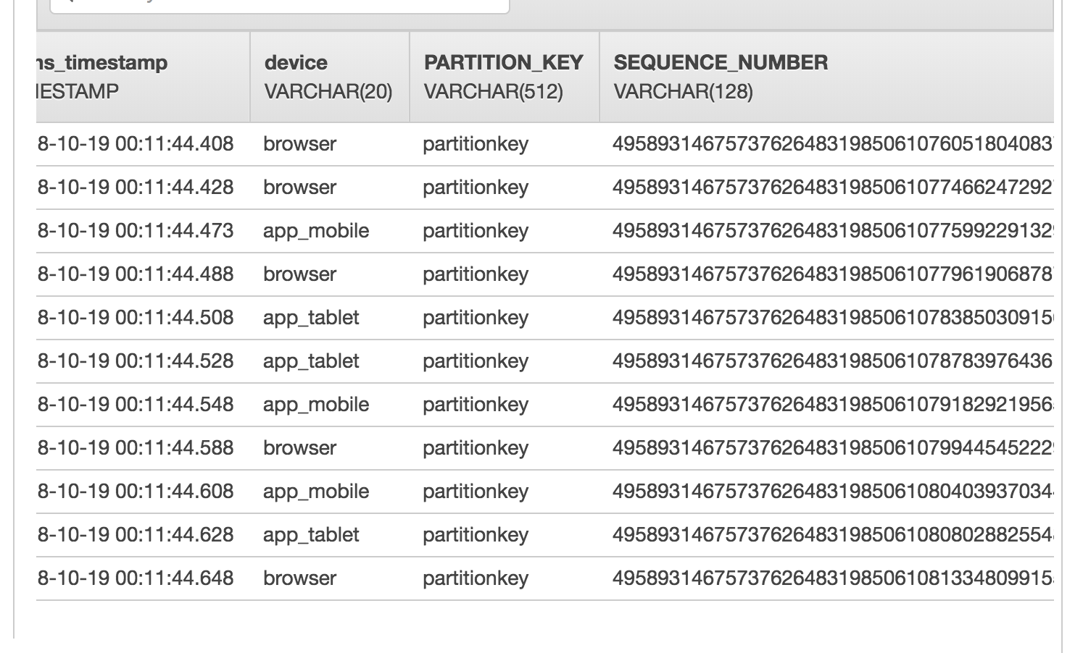

Click on real-time analytics and DESTINATION_SQL_STREAM:

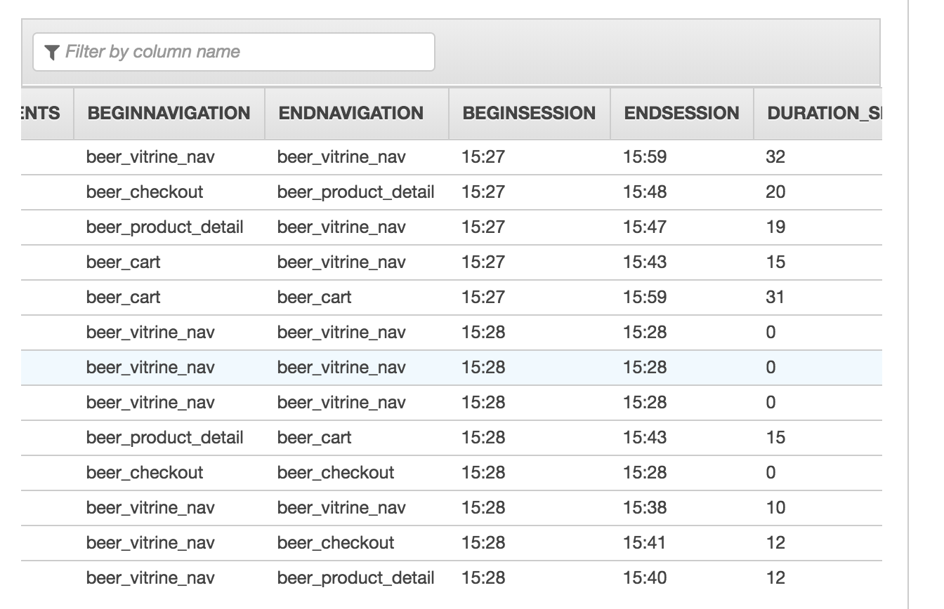

### Explore to the Destination Tab to Kinesis Firehose

Check the kinesis firehose destination setup to put the aggregated data in S3 :

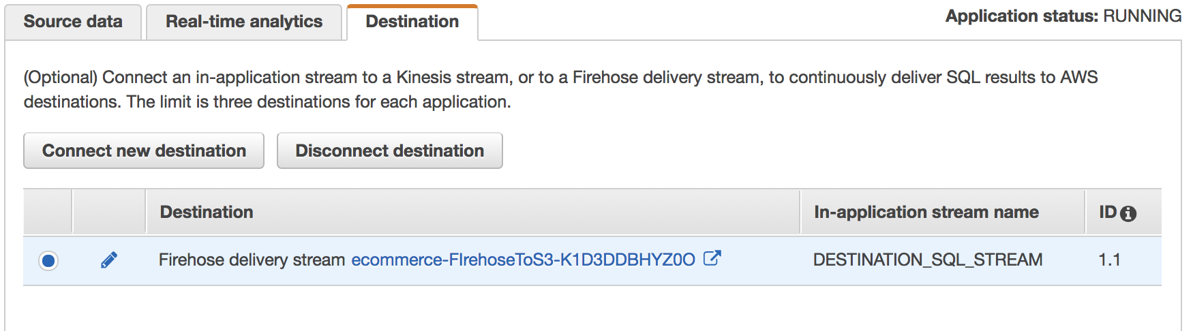

Click the FirehoseToS3 link :

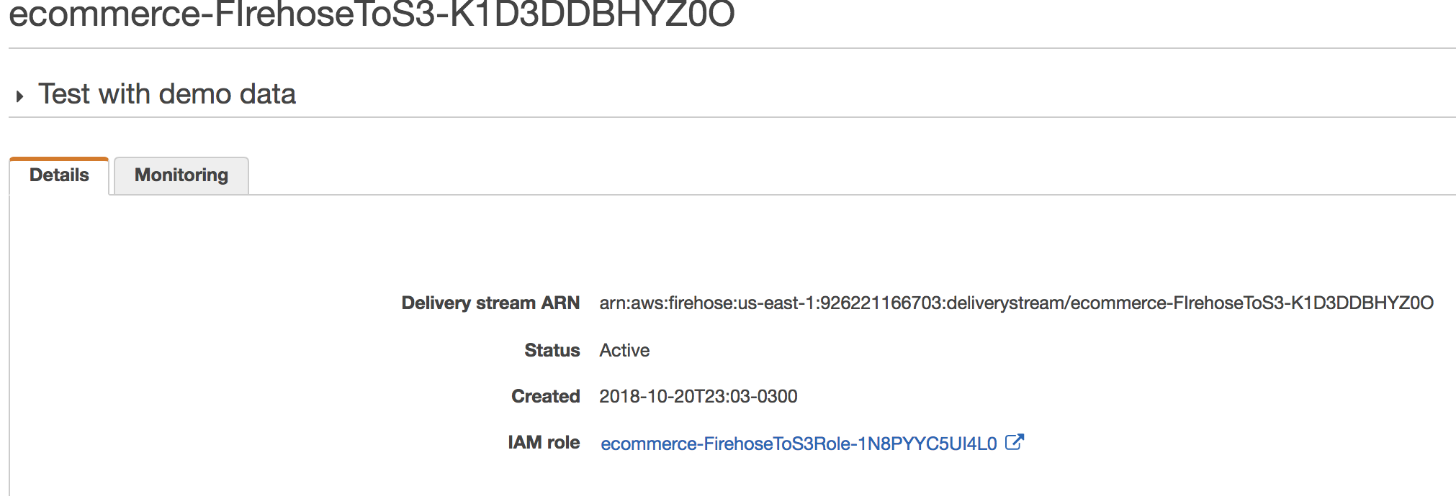

### Verify Amazon S3 console and what is in the bucket

<https://console.aws.amazon.com/s3/home?region=us-east-1>

Click in your bucket name “demo-ecommerce-<Account Number>” and see two folders “raw” and “aggregated”.

Wait and Refresh for a While to have aggregated data in the bucket.

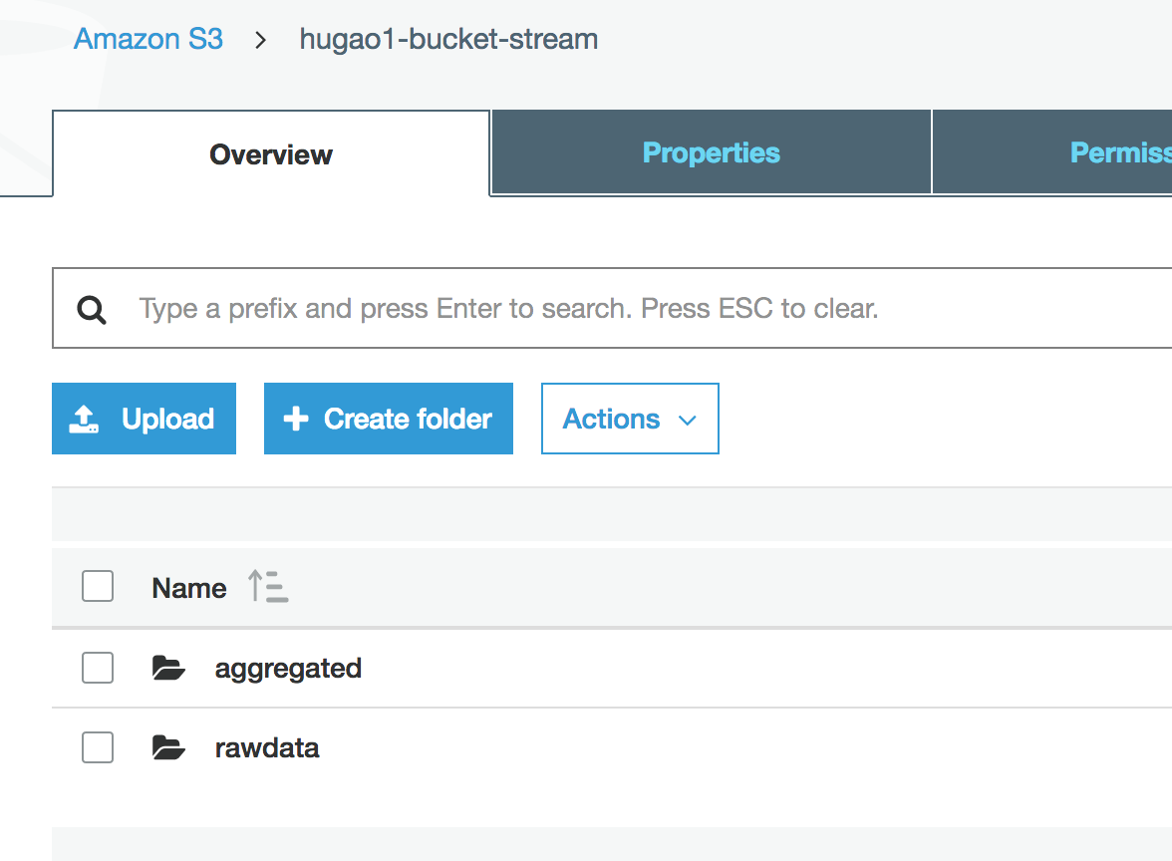

Navigate through the folders and check the files.

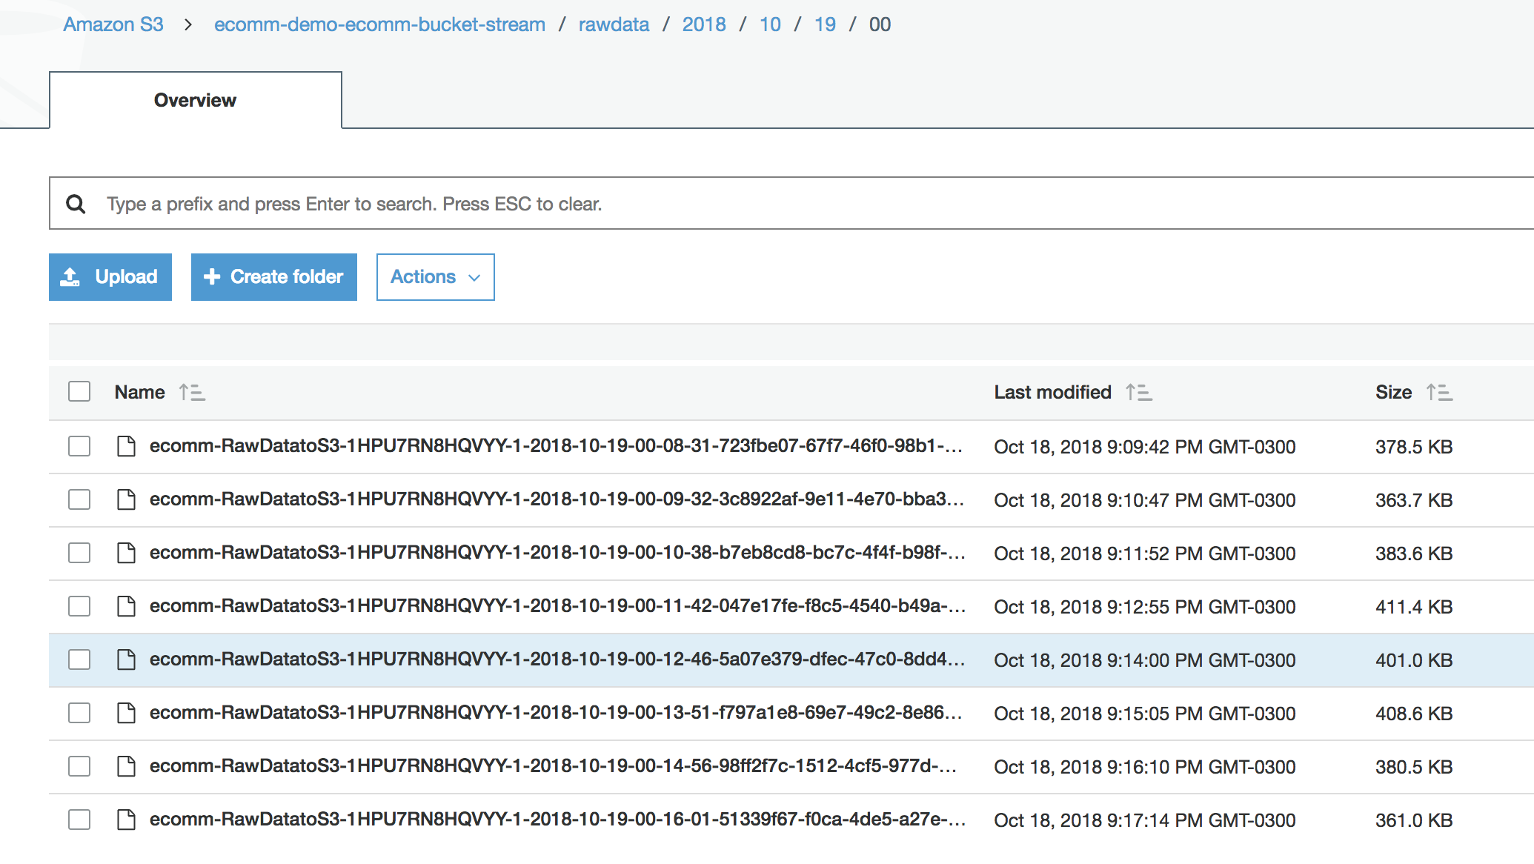

### Check CloudWatch Dashboard

<https://console.aws.amazon.com/cloudwatch/home?region=us-east-1#dashboards>:

Look for “DataAnalyticsStreaming-**ecommerce**-Streams<UID>”

View ingestion metrics calculated.

This Dashboard is constructed in order to follow up the ingestion and consumption of Kinesis Data Analytics, which aggregates records, in sessions.

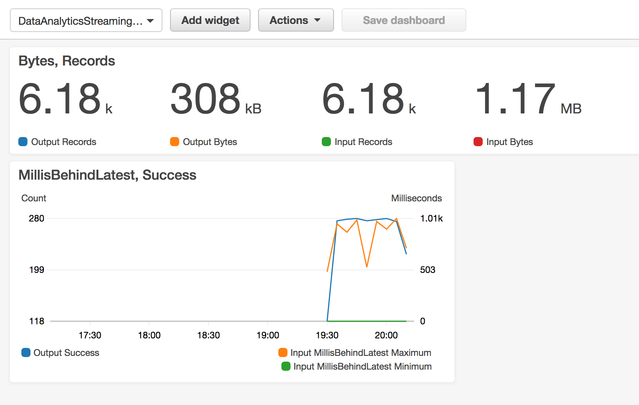

## Configurate Kibana

Go to Elasticsearch Dashboard.

[https://console.aws.amazon.com/es/home?region=us-east-1#](https://console.aws.amazon.com/es/home?region=us-east-1)

Click on Ecommerce elasticSearch .

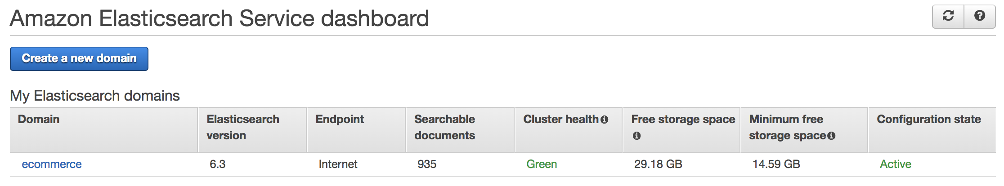

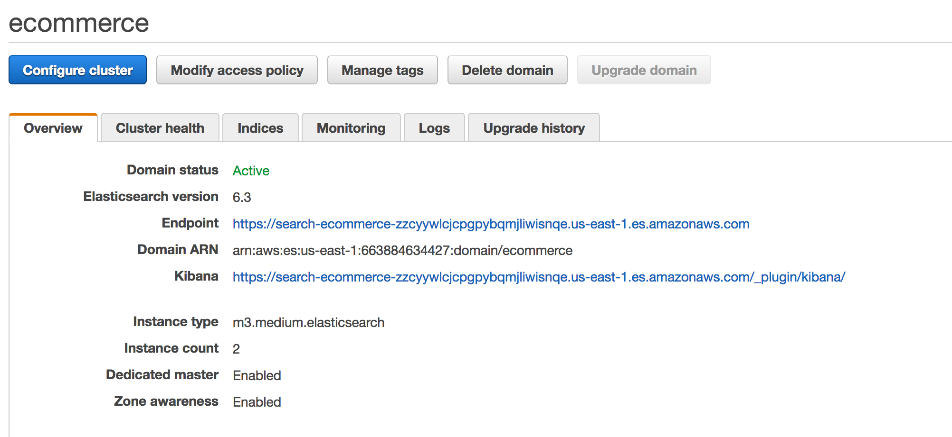

Click on Kibana link !

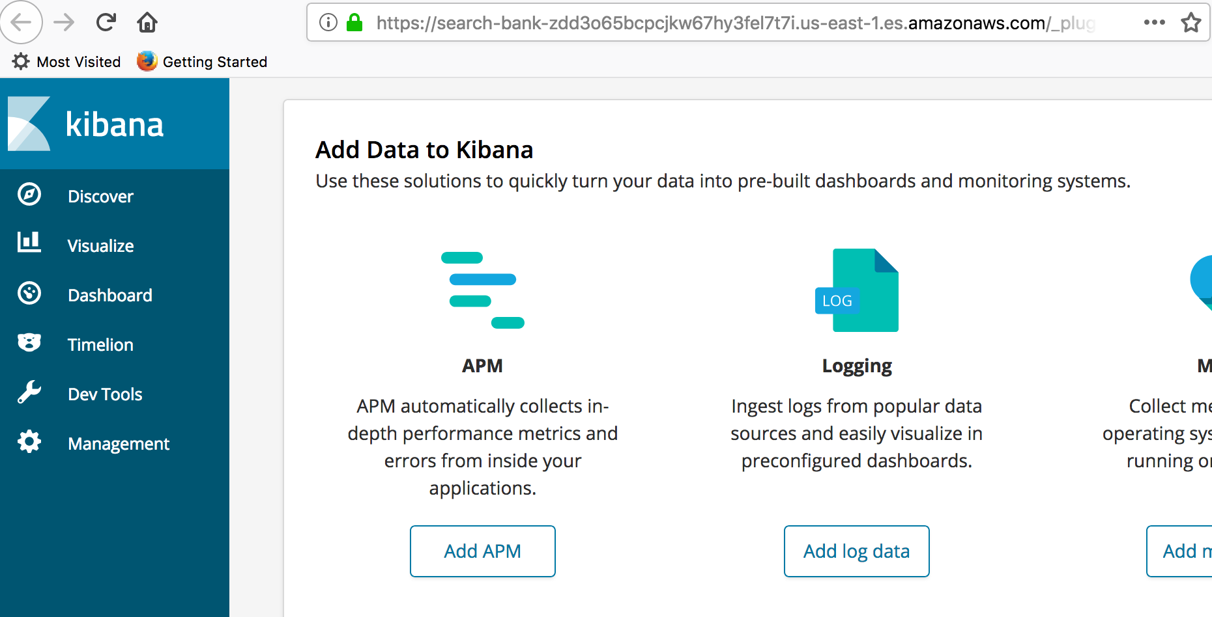

### Open Management to create an Index

The management option permits you to configure an Index.

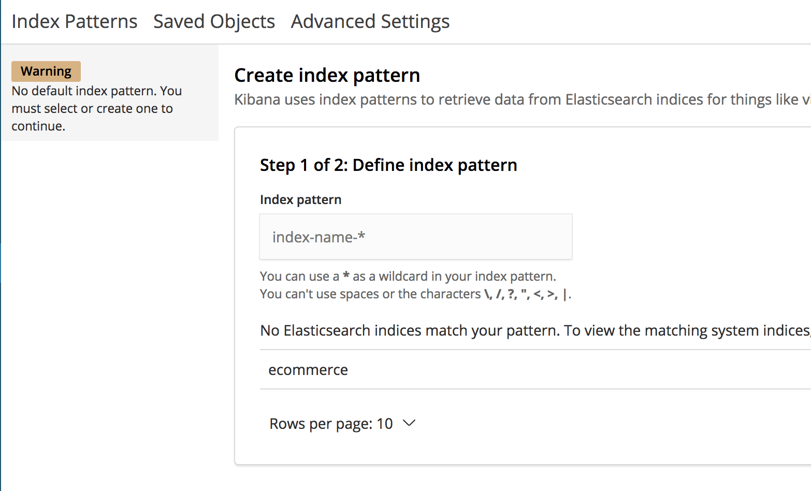

Write : **ecommerce** in the Index Pattern. Make sure you remove the “*” after the name.

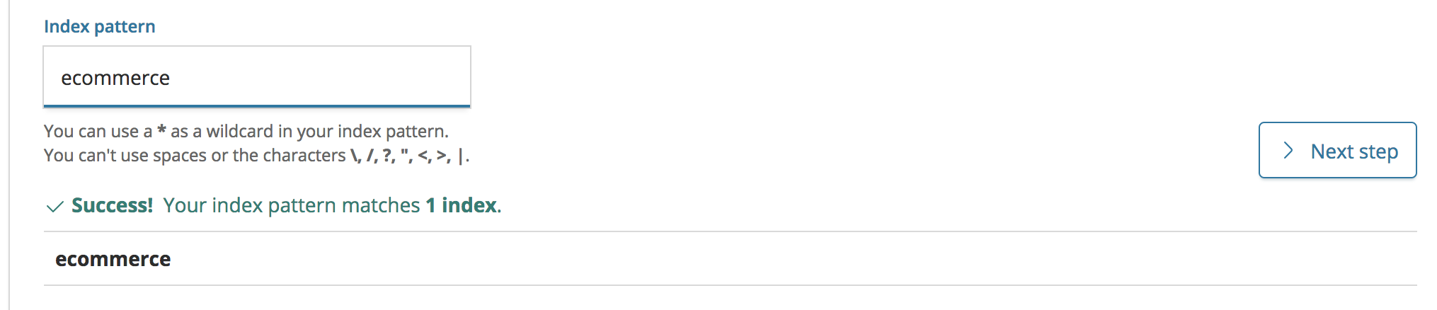

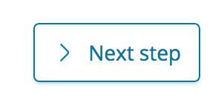

Select trans_timestamp as the time field for this index.

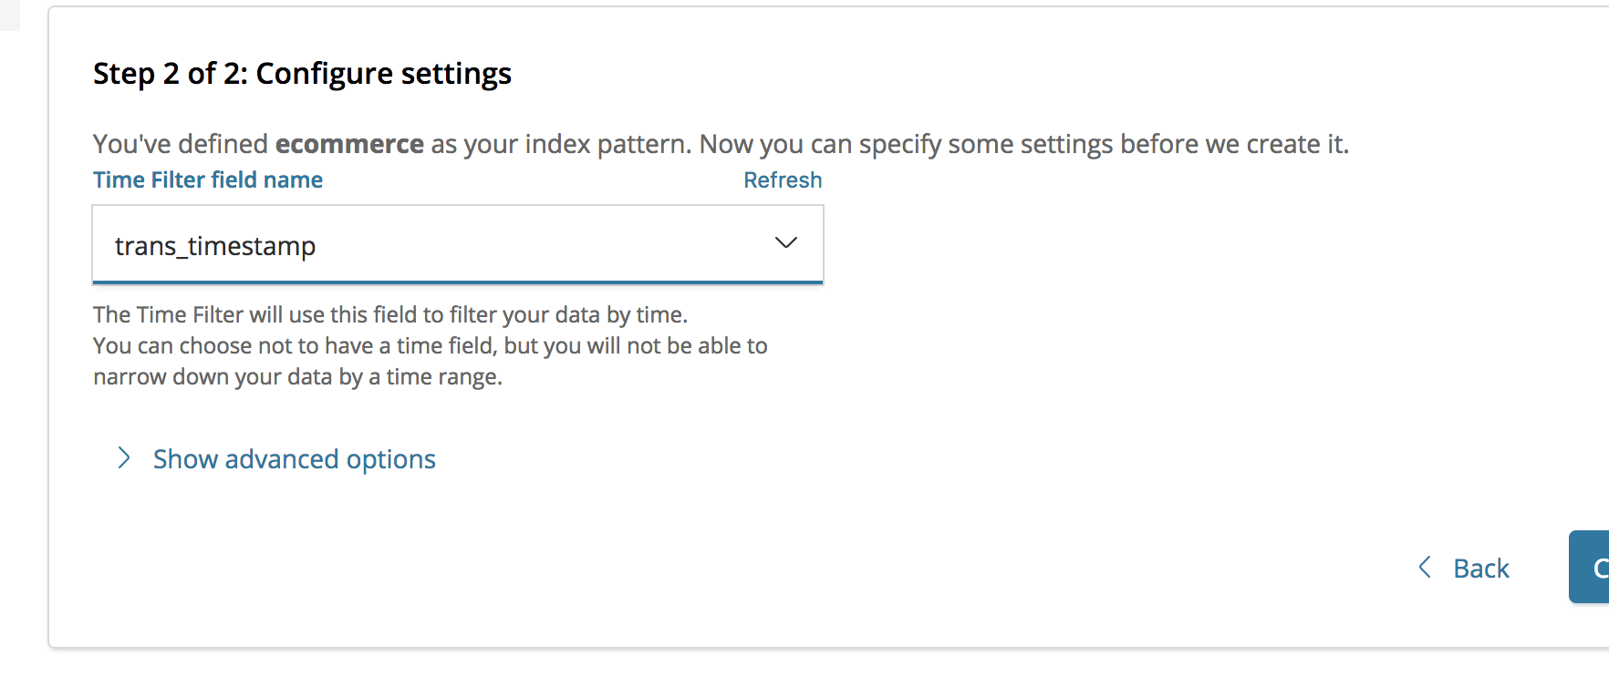

And Create the index pattern

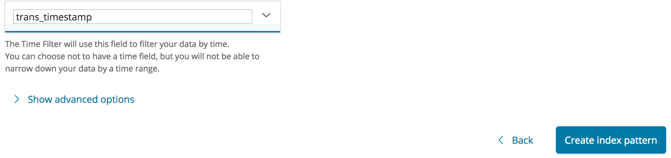

As a result you should see this:

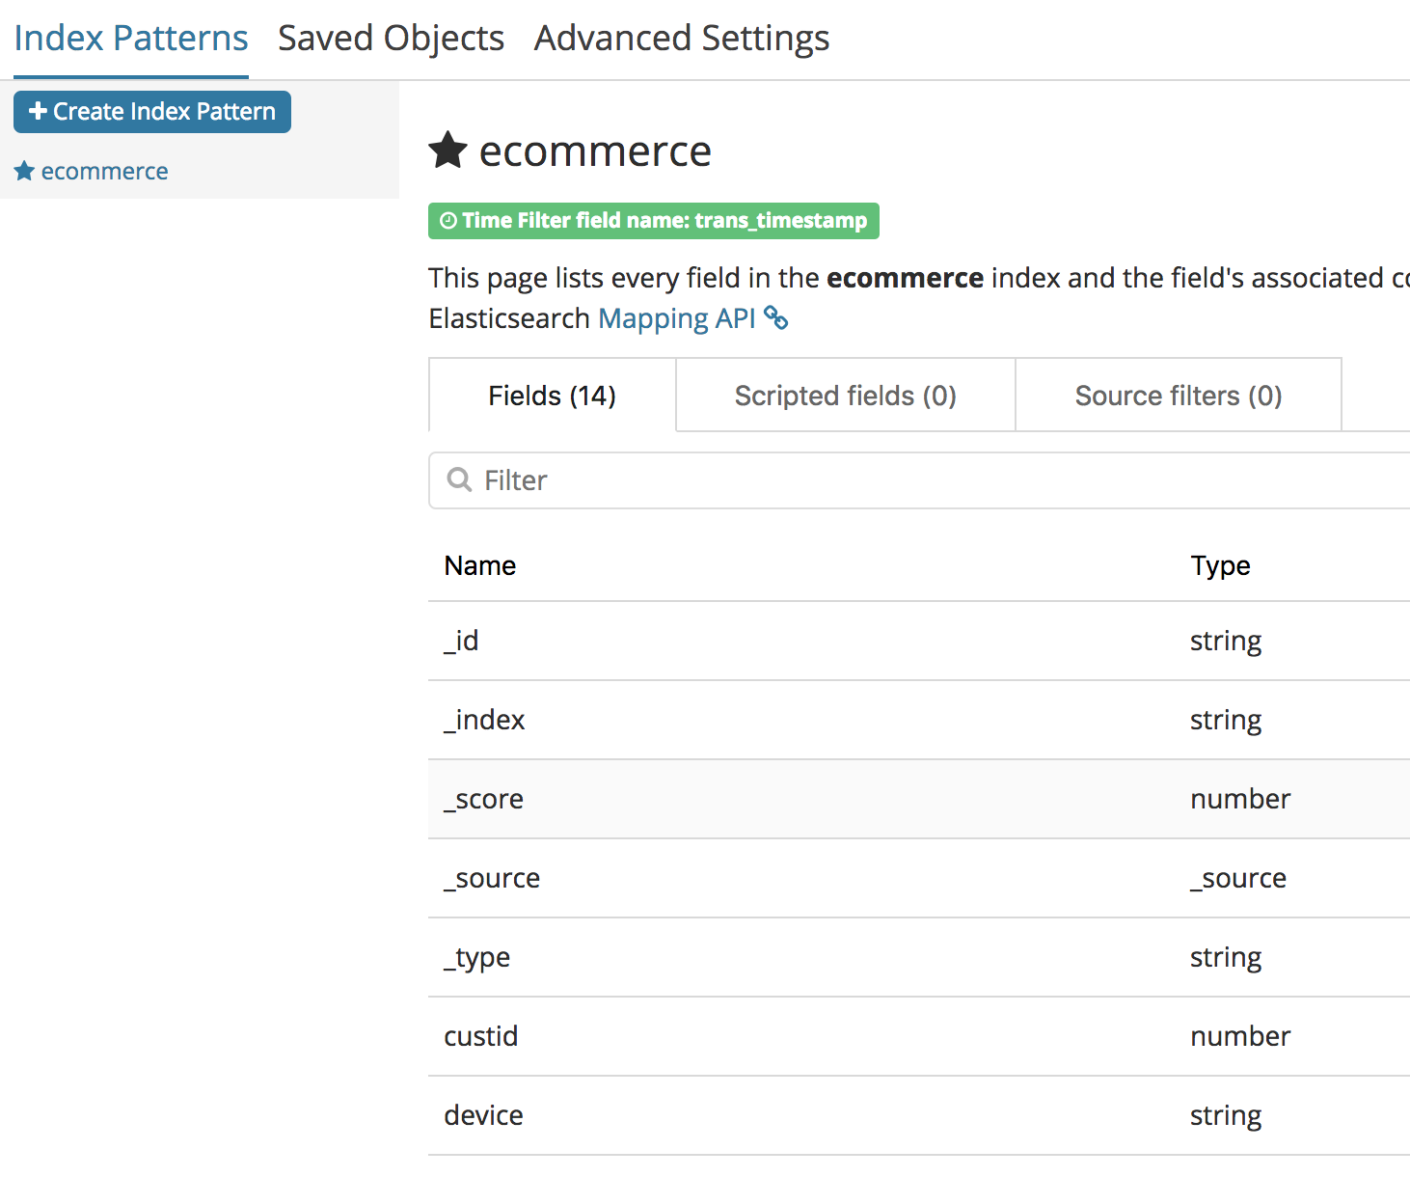

### Import a Dashboard for Ecommerce transactions

Download the file S3 :

<https://s3.amazonaws.com/assets-awsdemostore/kibanafiles/kibana_visual_ecommerce.json>

**Save (Use your Save AS from Browser) the content to a file :** kibana_visual_ecommerce.json file in your computer

In Kibana web UI go to Management -> Saved Objects

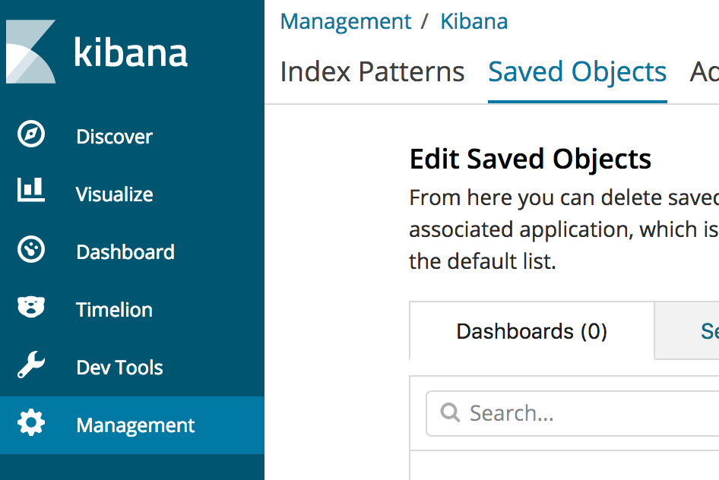

**At the top Right click on Import :**

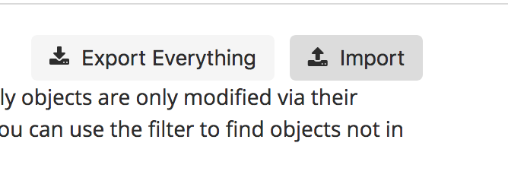

**Select the file you have downloaded :**

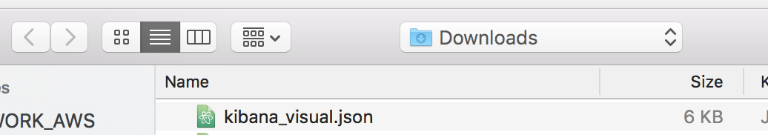

**Select OverWrite**

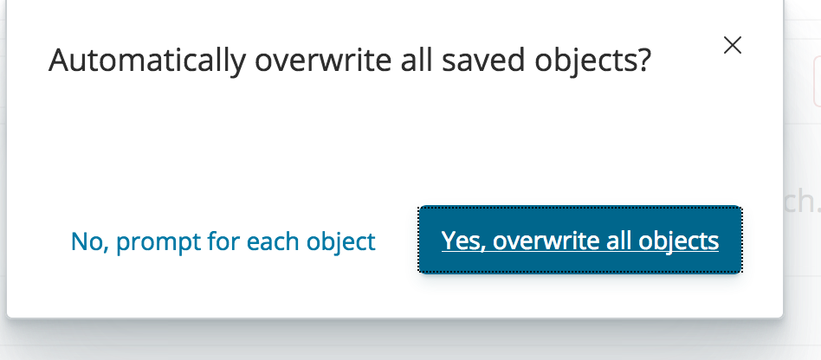

**Confirm All Changes -** as we have created the Index before, it will be recreated from the file with the dashboard.

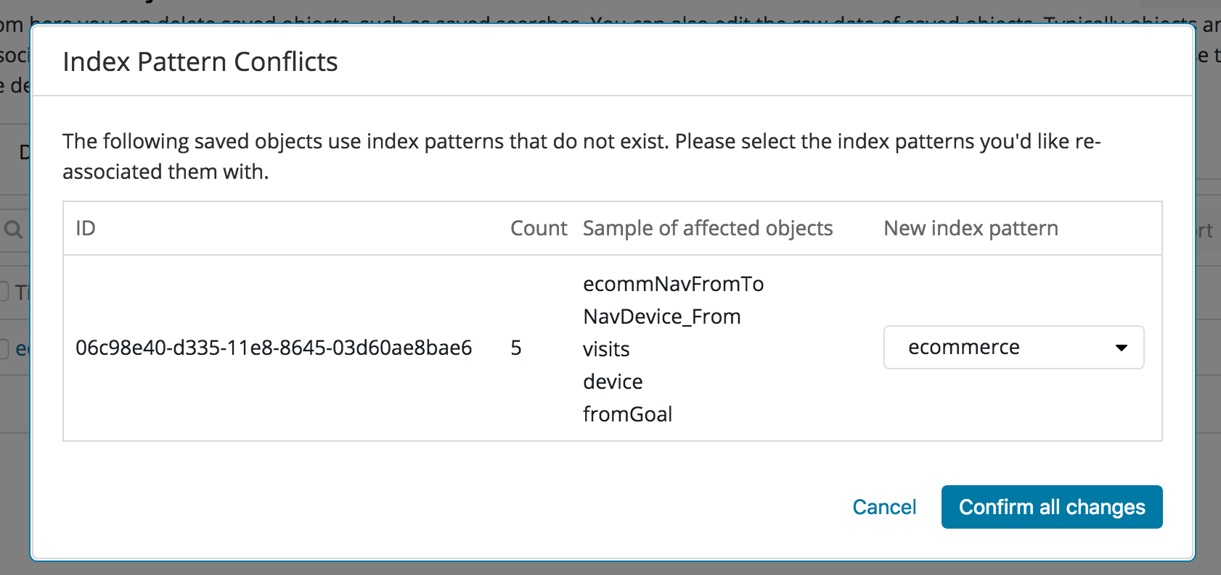

### Access the Dashboard for Ecommerce transactions

Go to the Dashboard menu and click on **ecommerce**

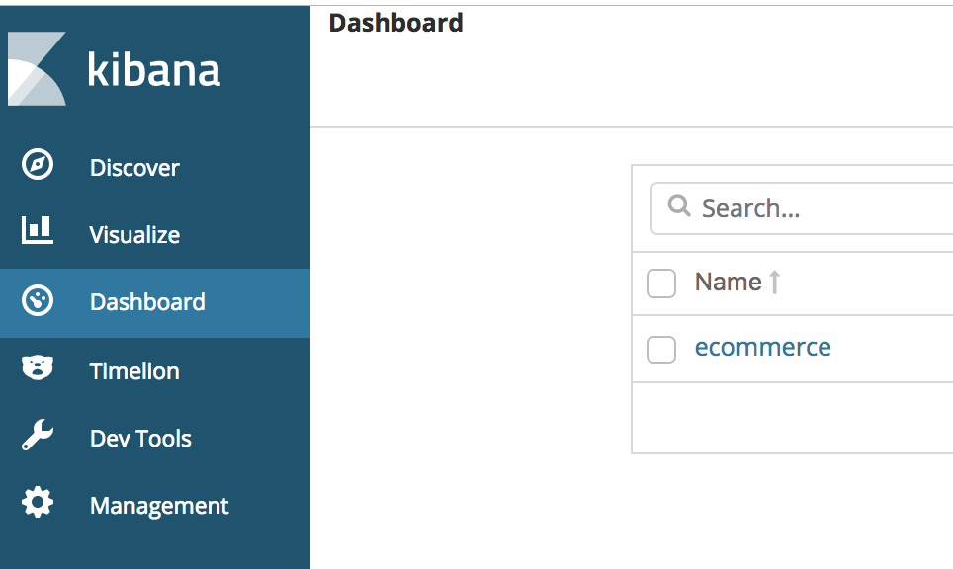

The time window is set to Last 15 minutes, but our data is from a different timezone.

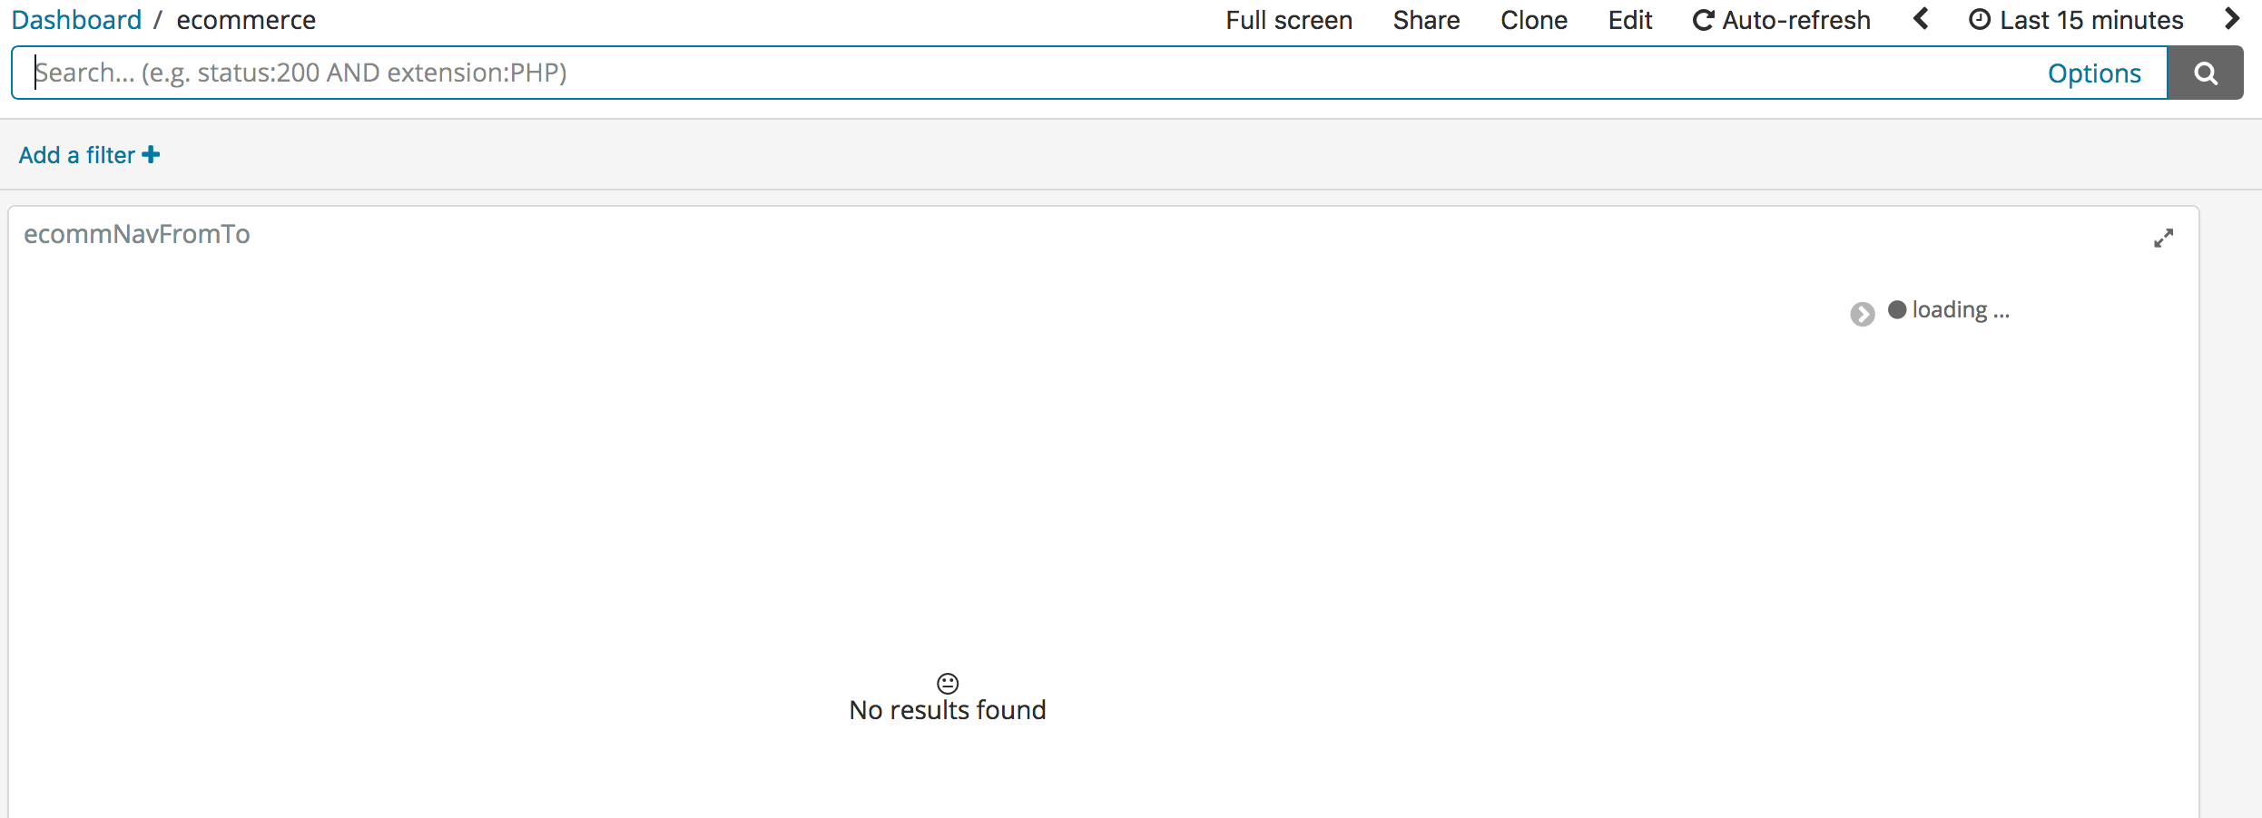

Change the window time to **Last 4 hours** to adjust the Timezone .

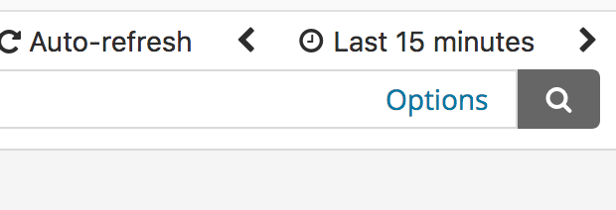

Change it to 4 hours :

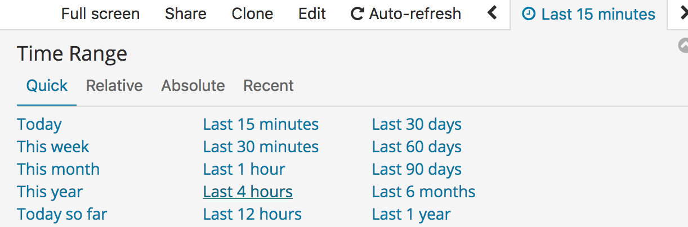

You should have this dashboard:

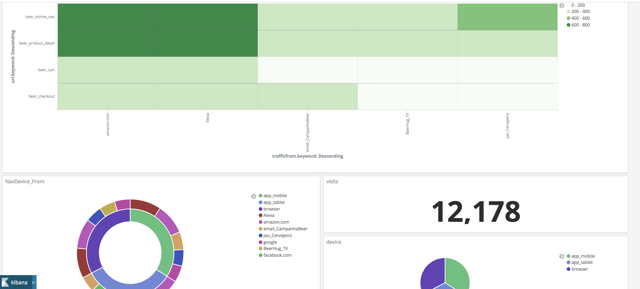

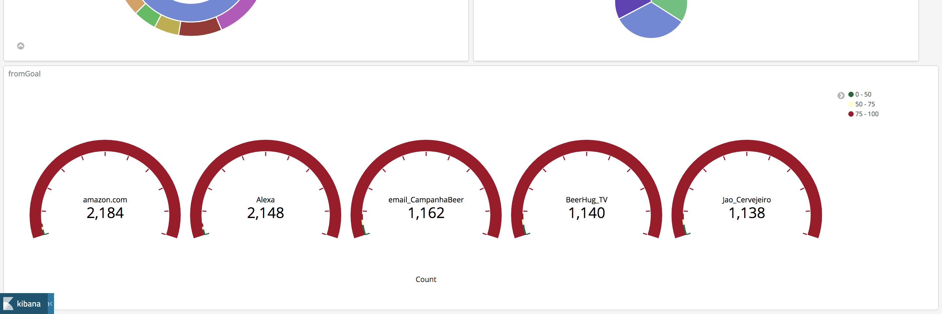

## 

## Crawler the S3 to pick table definition on Glue

<https://console.aws.amazon.com/glue/home?region=us-east-1#catalog:tab=crawlers>

Go to the Glue menu and click on Crawler, choose **demoecommerce.**

Mark the job and click Run crawler.

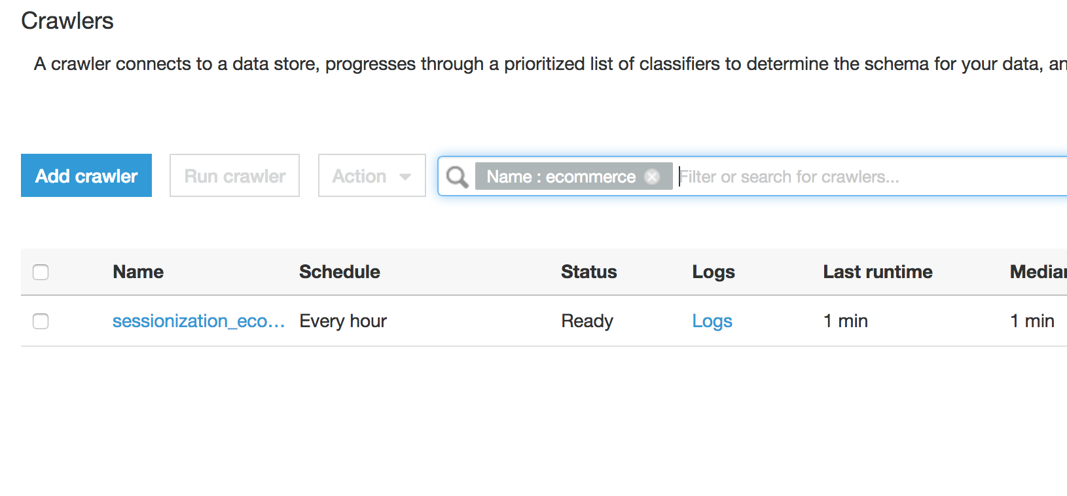

Mark the JOB and click Run crawler

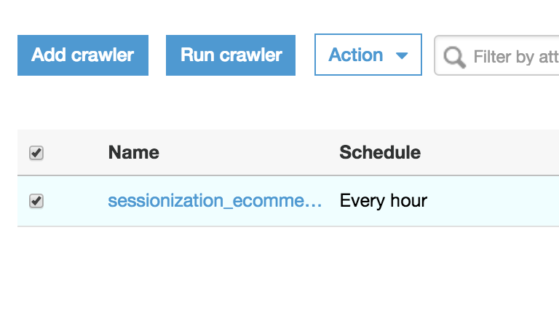

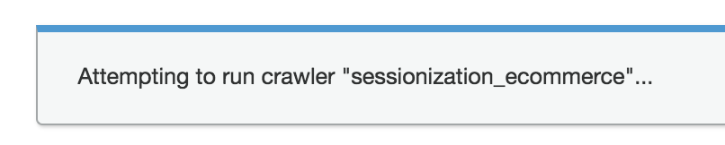

After the completion of the job you should see:

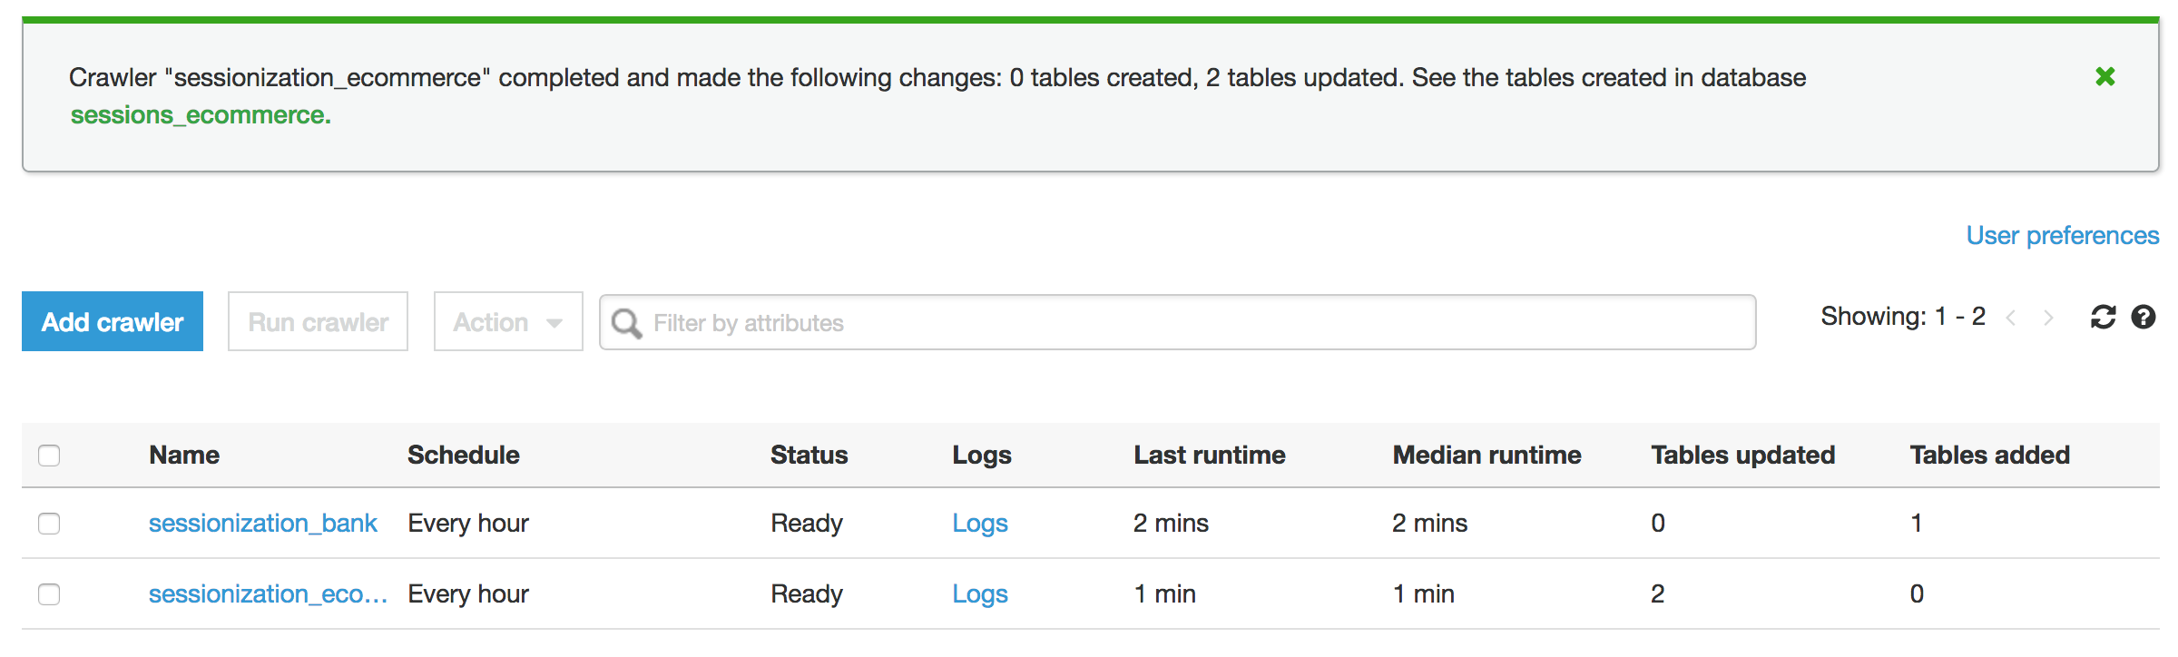

## Query Data in Amazon Athena

<https://console.aws.amazon.com/athena/home?region=us-east-1#query>

Go to the Athena menu and click on Databases, choose **sessions_ecommerce_ .**

Click on Get Started. Then click ( x ) to exit tutorial .

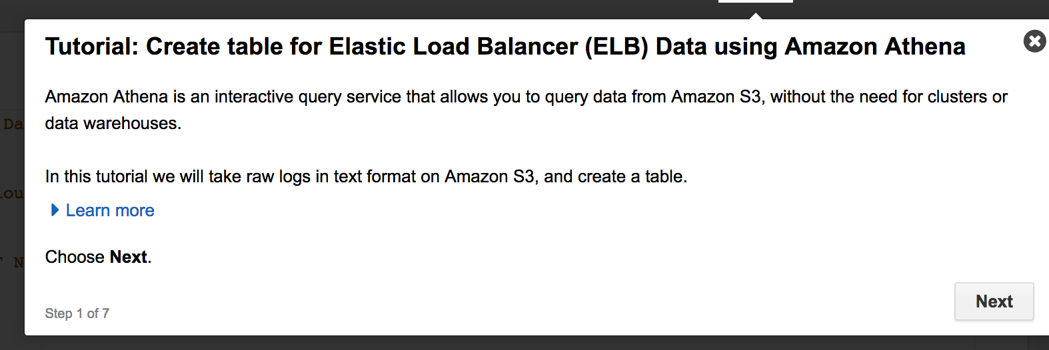

Choose database session_ecommerce:

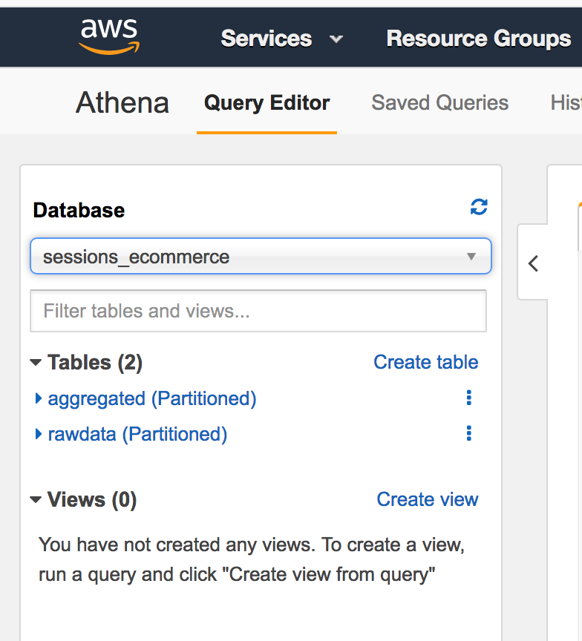

**You should see two tables :**

Click on the {…} points aside rawdata table and Preview.

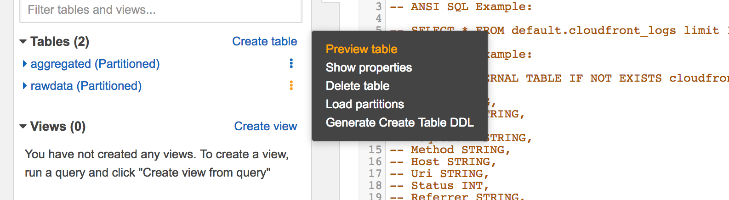

To check table data.

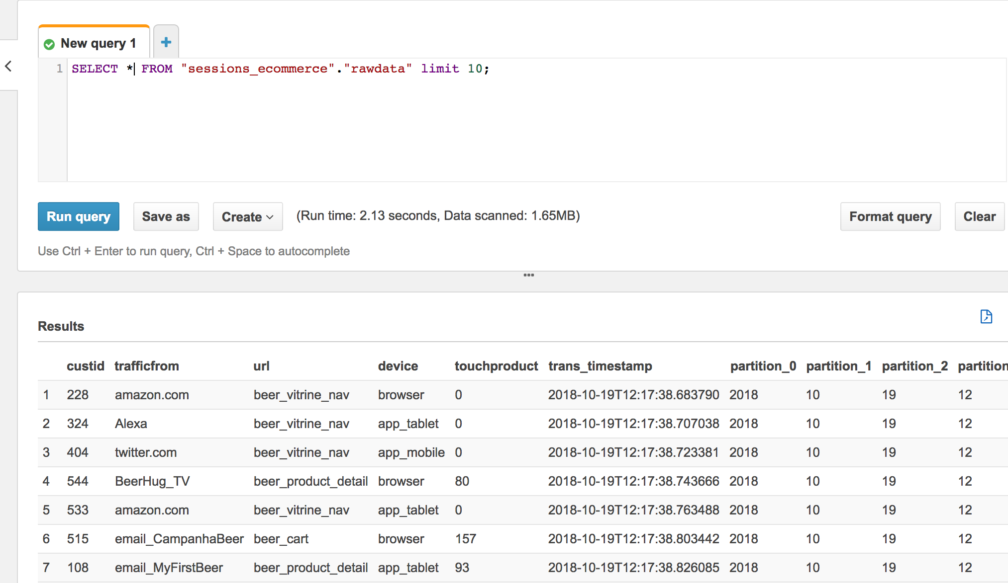

Explore the product is the most touched.

SQL

SELECT touchproduct, count(1) touched

FROM "sessions_ecommerce"."rawdata"

where touchproduct >0

group by touchproduct

order by 2 desc;

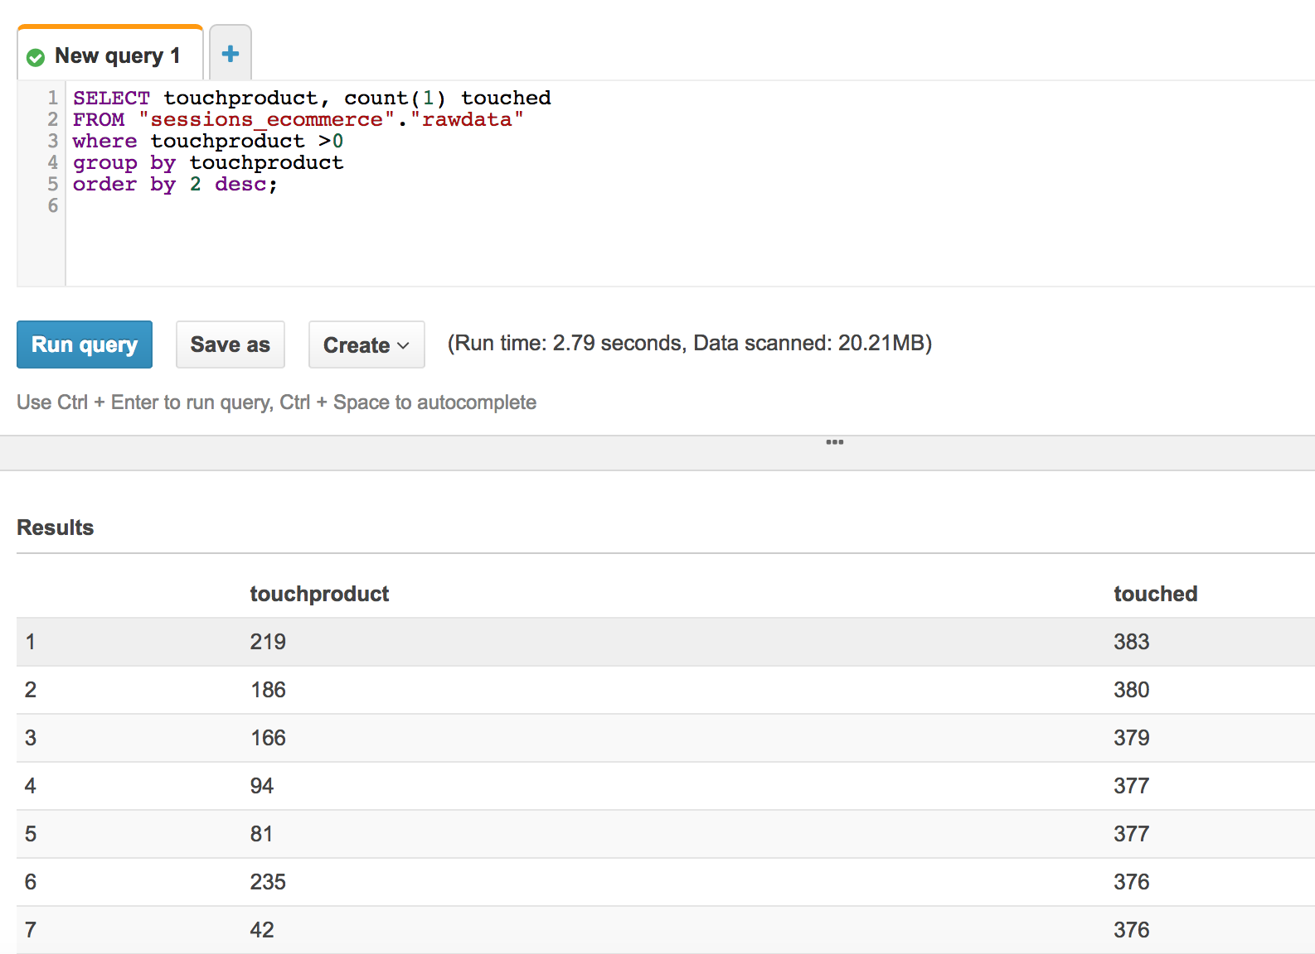

Create a View from Athena to query data with Column names:

CREATE OR REPLACE VIEW "view_aggregated" AS

select col0 as sessionid,

col1 as userid,

col2 as device,

col3 as aggreg_time,

col4 as events,

col5 as beginurl,

col6 as endurl,

col7 as begin_min_ss,

col8 as end_min_ss,

col9 as totaltime_sec,

partition_0 as year,

partition_1 as month,

partition_2 as day,

partition_3 hour

from sessions_ecommerce.aggregated;

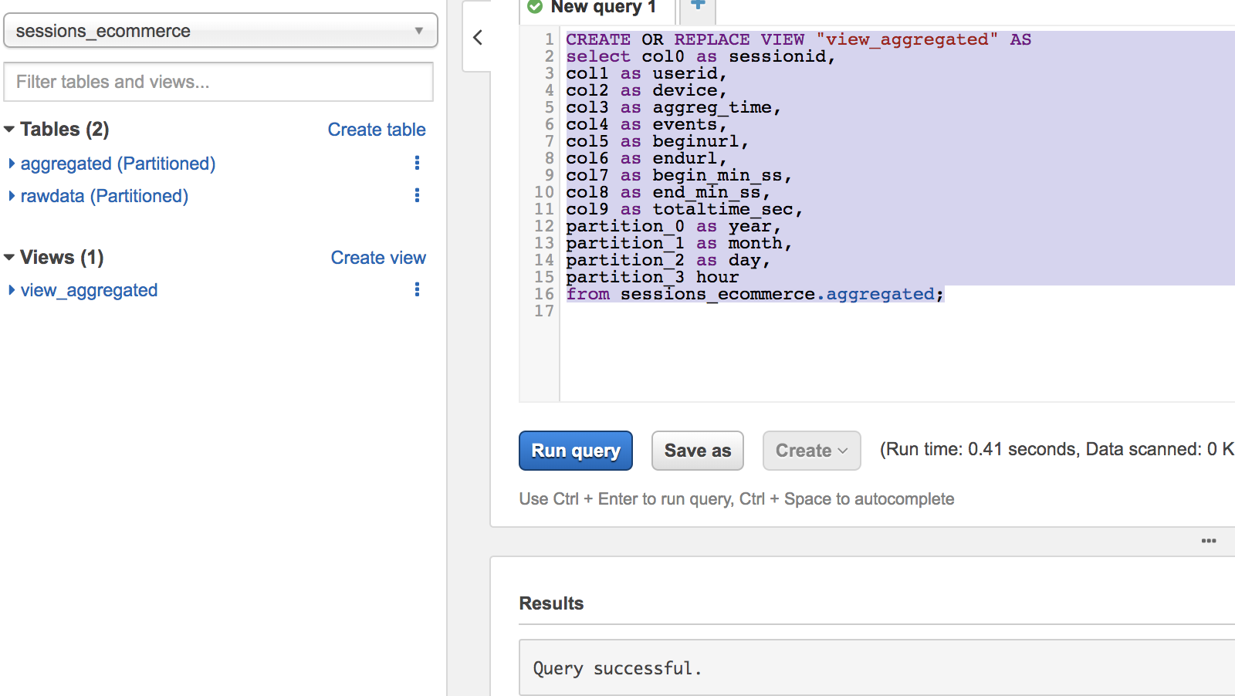

## 

## You can Adjust Column names on Glue for aggregated Data – Skip this Step

Go to the Glue console, Tables: aggregated, Database sessions_ecommerce.

<https://console.aws.amazon.com/glue/home?region=us-east-1#table:name=aggregated;namespace=sessions_ecommerce>

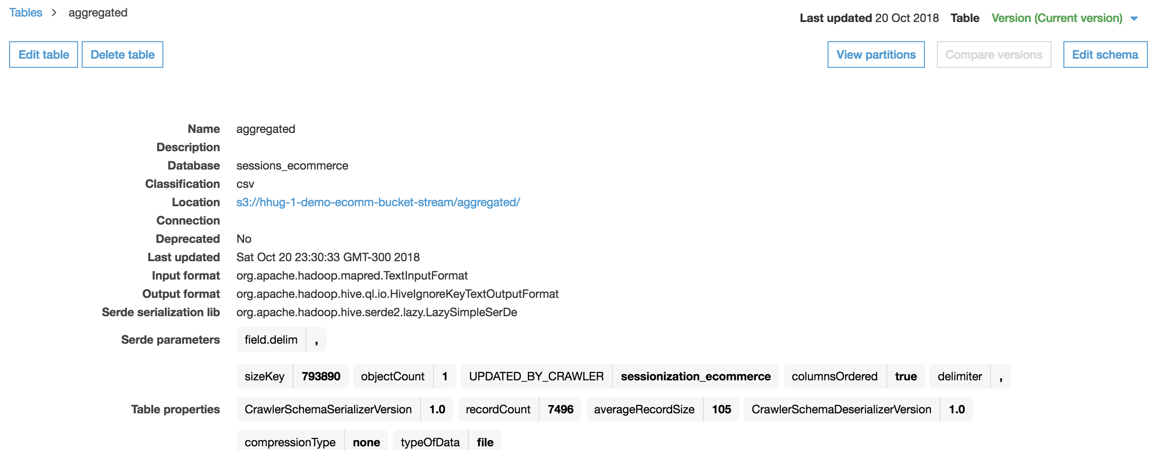

Click on **Edit Schema** to change column names.

**Change column names :**

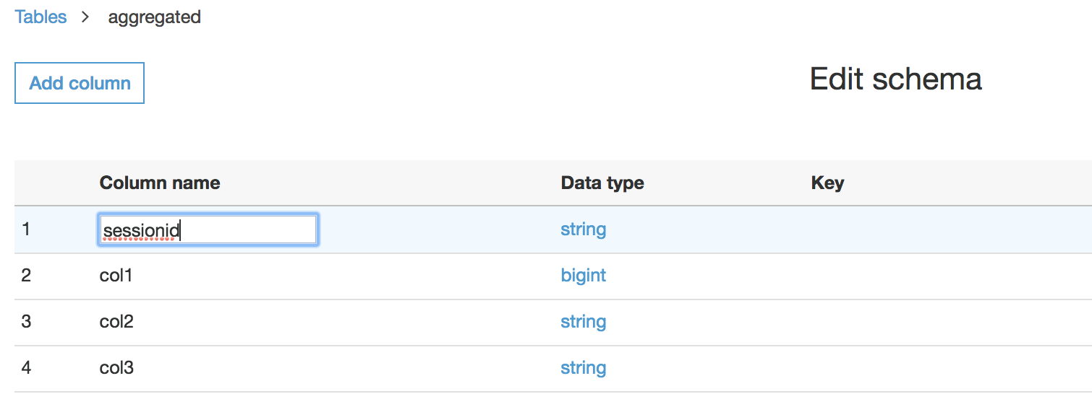

|  |  |
| --- | --- |
| **Current Value** | **Change to** |
| col0 | sessionid |
| col1 | userid |
| col2 | device |
| col3 | aggreg_time |
| col4 | events |
| col5 | beginurl |
| col6 | endurl |
| col7 | begin_min_ss |
| col8 | end_min_ss |
| col9 | totaltime_sec |
| partition_0 | year |
| partition_1 | month |
| partition_2 | day |
| partition_3 | hour |

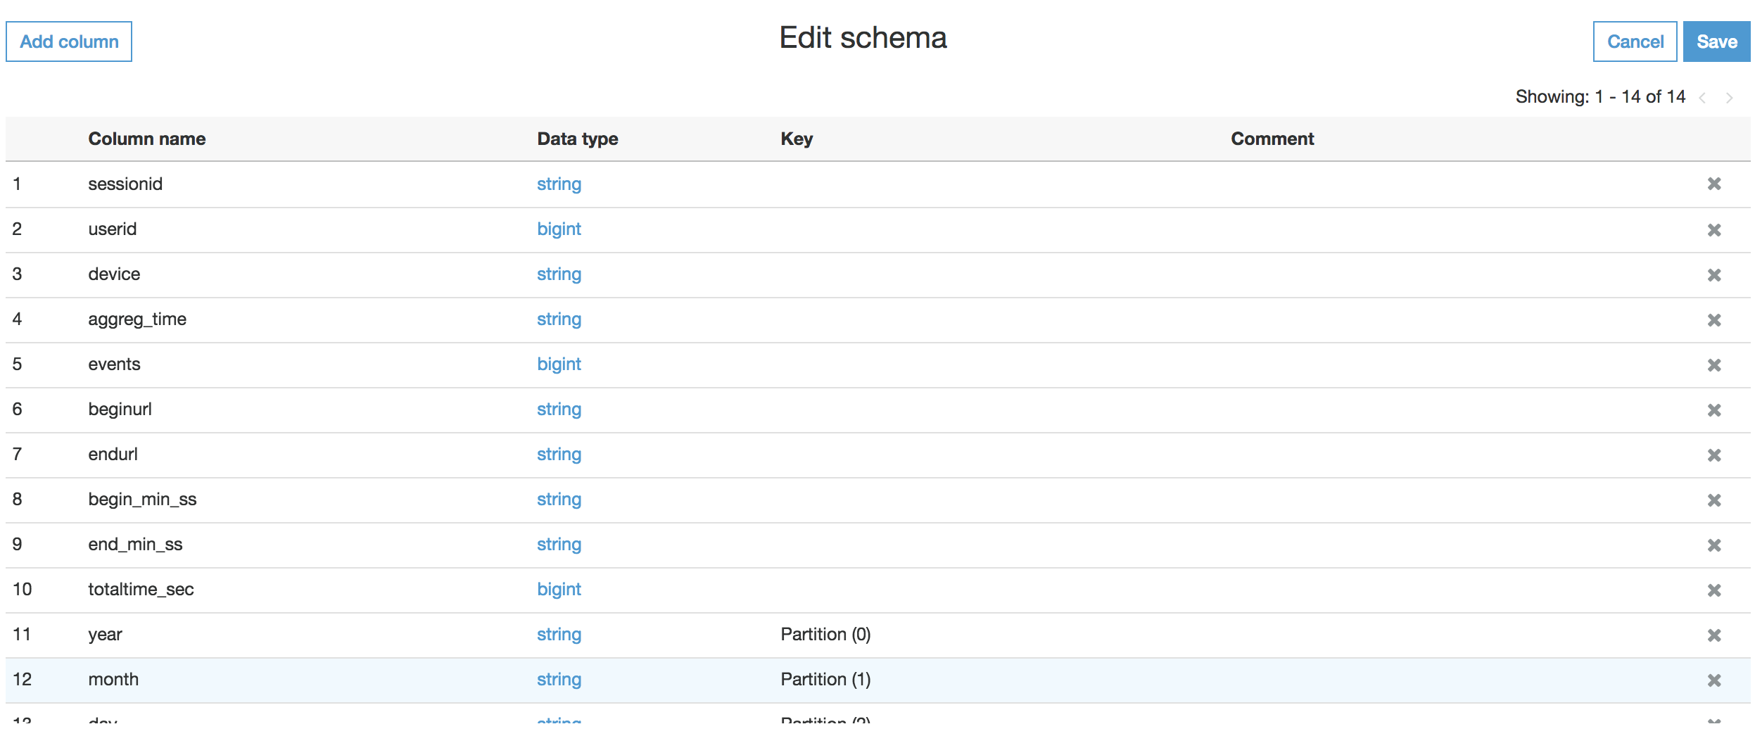

Then save:

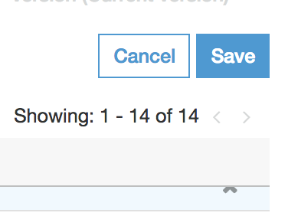

## Query aggregated data table in Amazon Athena

<https://console.aws.amazon.com/athena/home?region=us-east-1#query>

Go to the Athena menu and click on Databases, choose **sessions_ecommerce_ .**

Execute the SQL:

SELECT device, avg(totaltime_sec) avgtime, max(totaltime_sec) maxtime

FROM "sessions_ecommerce"."view_aggregated"

group by device;

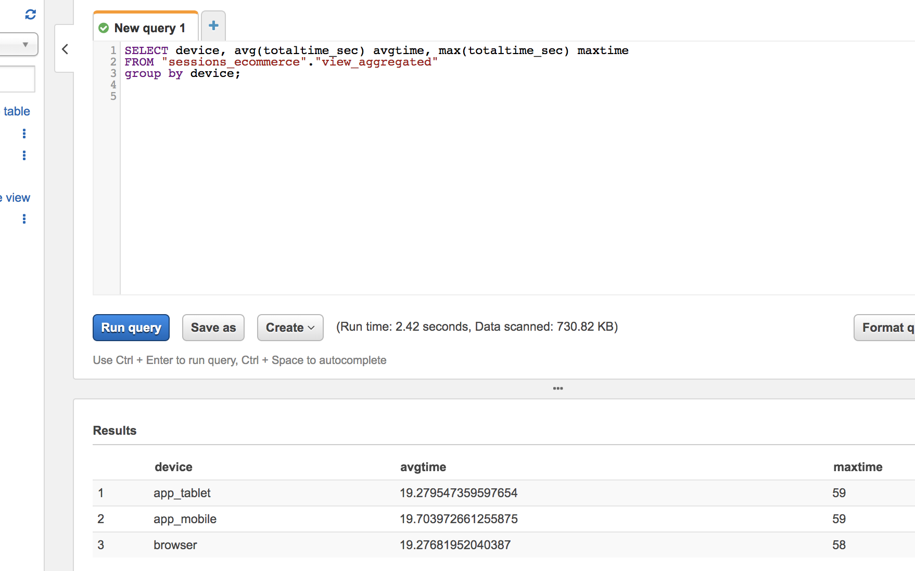

## Go to Athena to see the database you have created and preview the tables

<https://us-east-1.console.aws.amazon.com/athena/home?region=us-east-1#query>

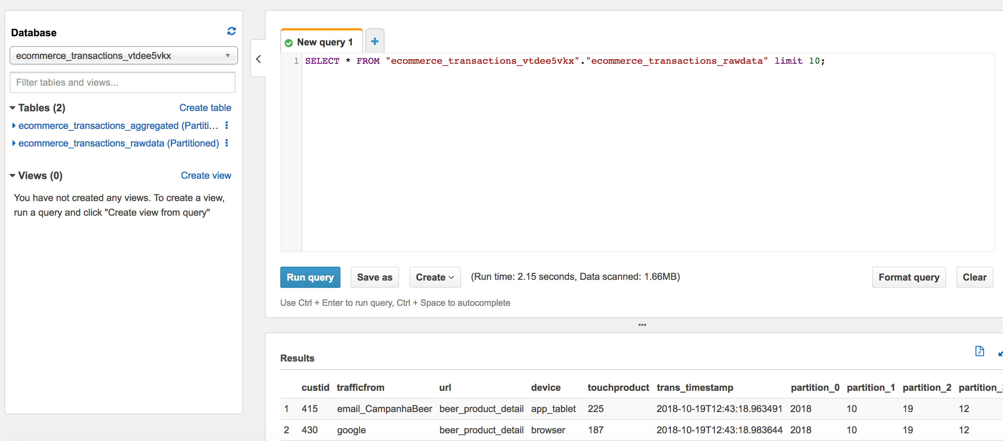

Preview the tables:

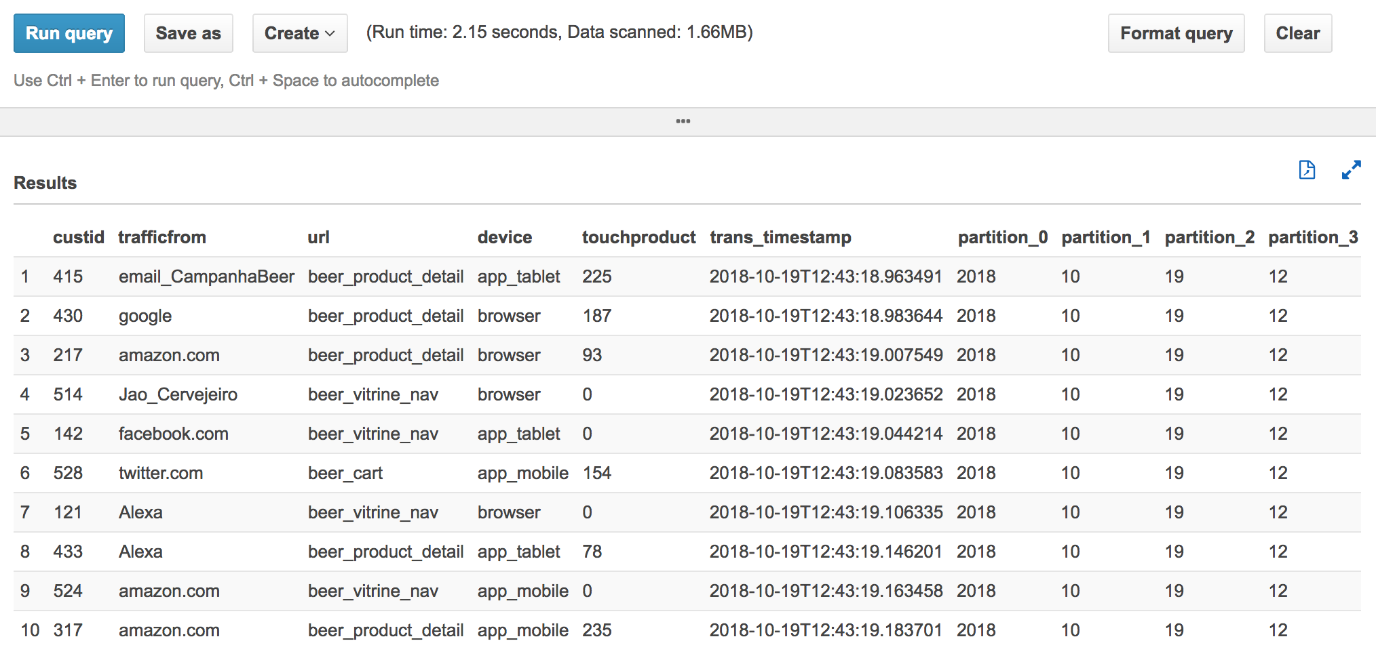

# Visualize Data with Amazon Quicksight

Go to Amazon Quicksight console.

<https://quicksight.aws.amazon.com/sn/start>

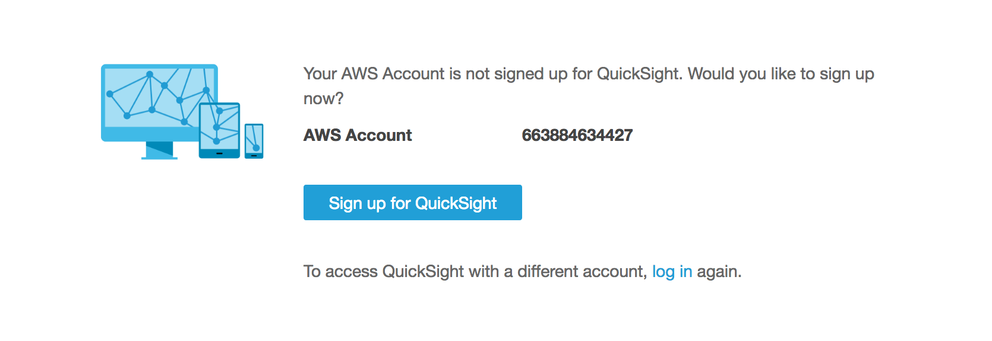

Click Sign up for QuickSight

Choose Enterprise for the QuickSight.

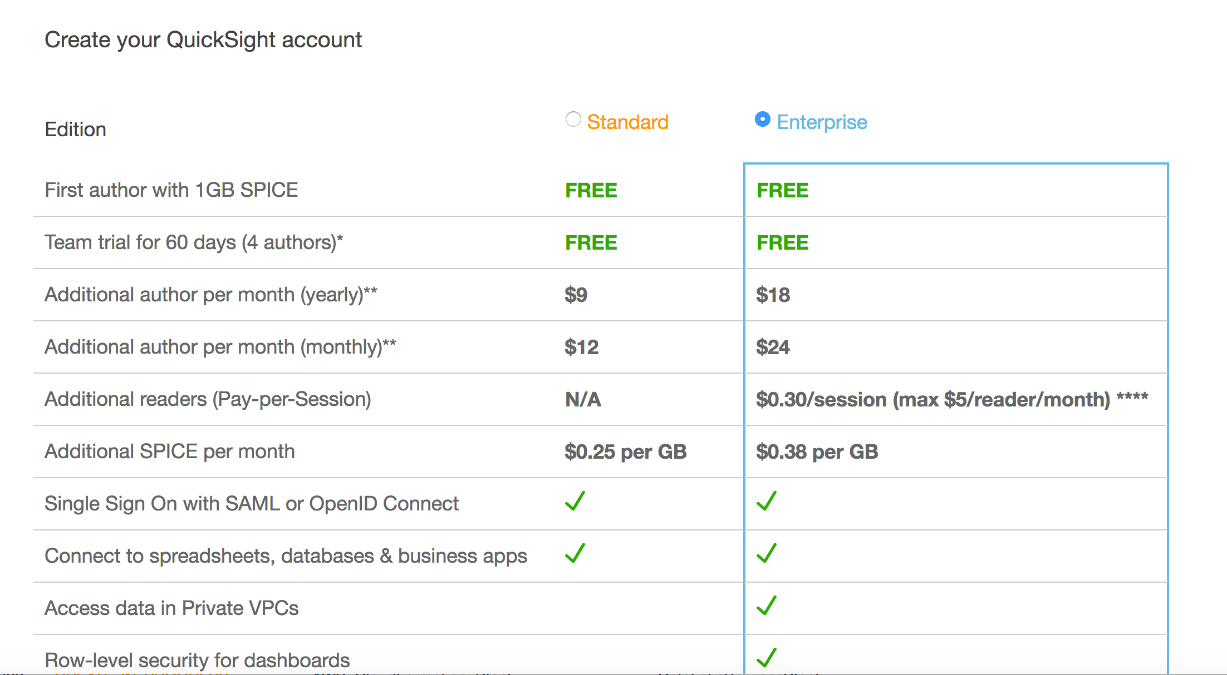

## Setup permissions to access Athena and S3 from Quicksight

Create a name for Quicksigh account and put your email for Quicksigh administration :

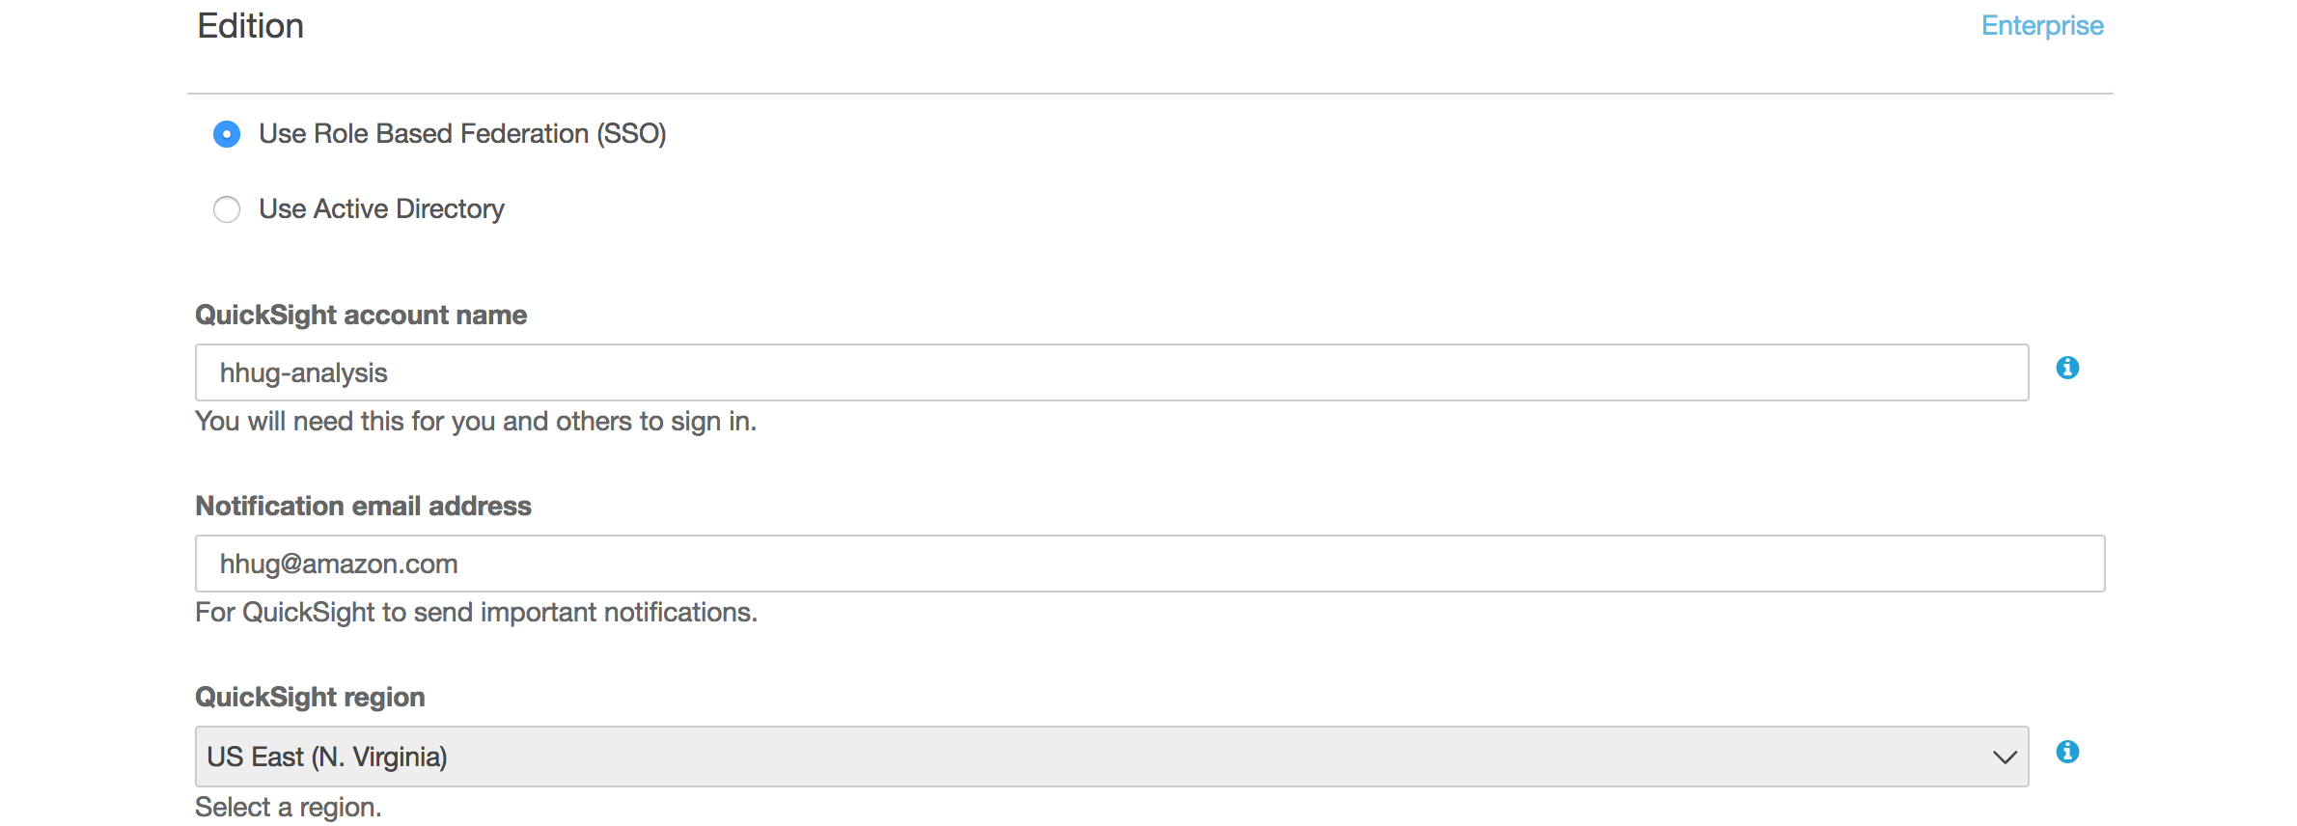

Account Name : yourname-analysis

Email : your email

Amazon S3 to Choose Buckets if need us this link : [https://us-east-1.quicksight.aws.amazon.com/sn/console/resources?#](https://us-east-1.quicksight.aws.amazon.com/sn/console/resources?)

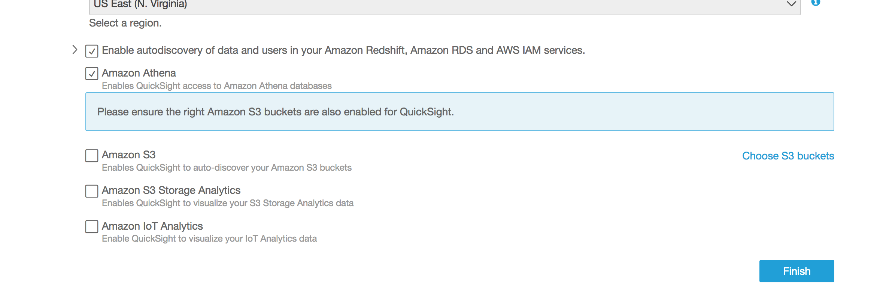

Mark Amazon S3 and Choose your S3 Buckets:

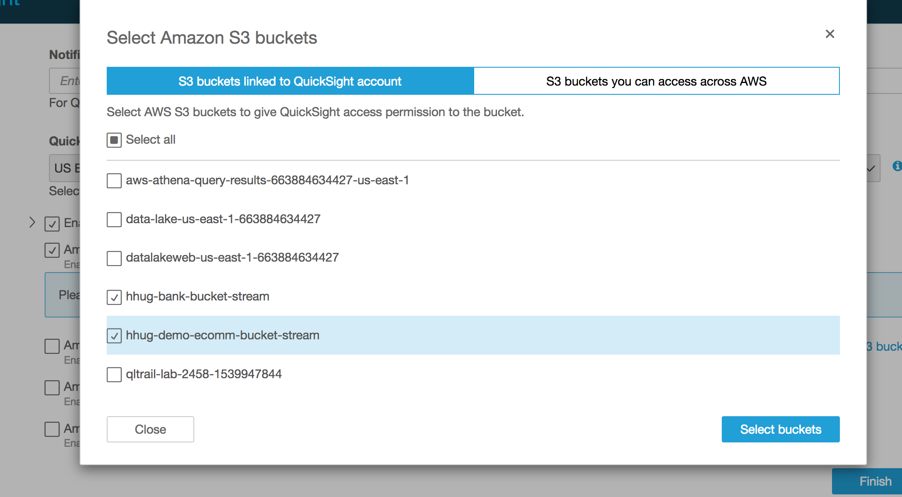

Then click Finish:



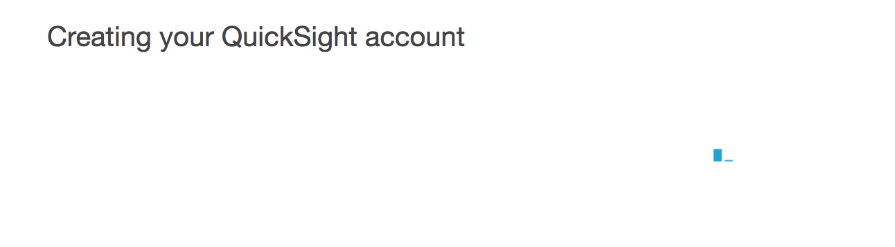

## Create a Data Source in Amazon Quicksight

<https://us-east-1.quicksight.aws.amazon.com/sn/start>

Choose manage Data :

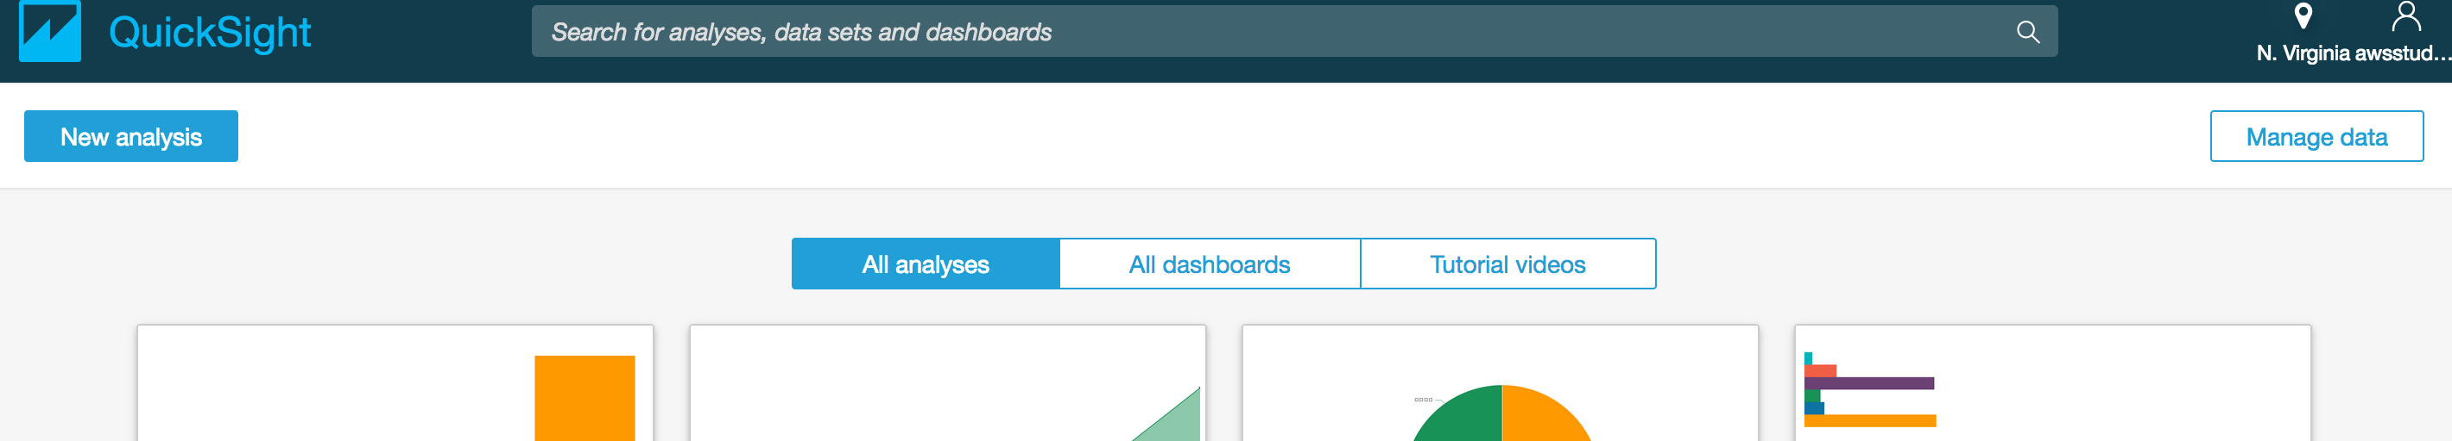

Click Manage Data.

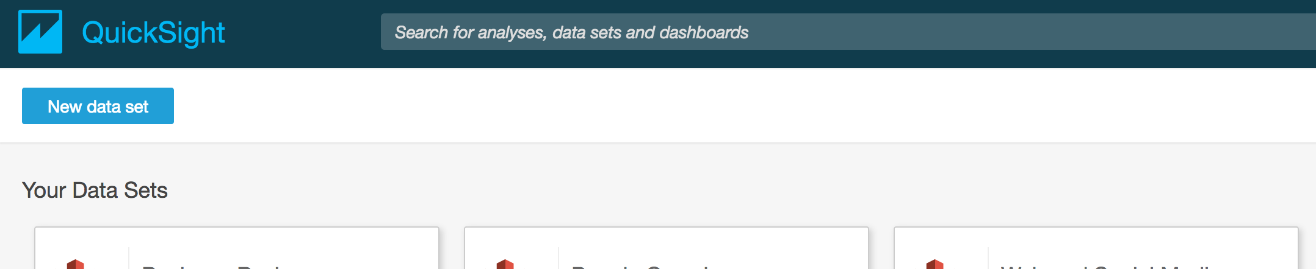

Select New data Set!

Pick Athena as Data Source :

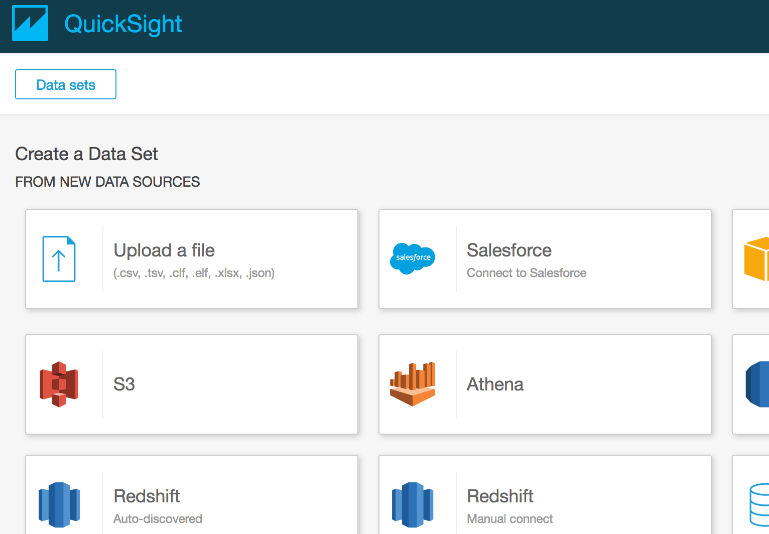

Data Source Name: sessions_ecommerce

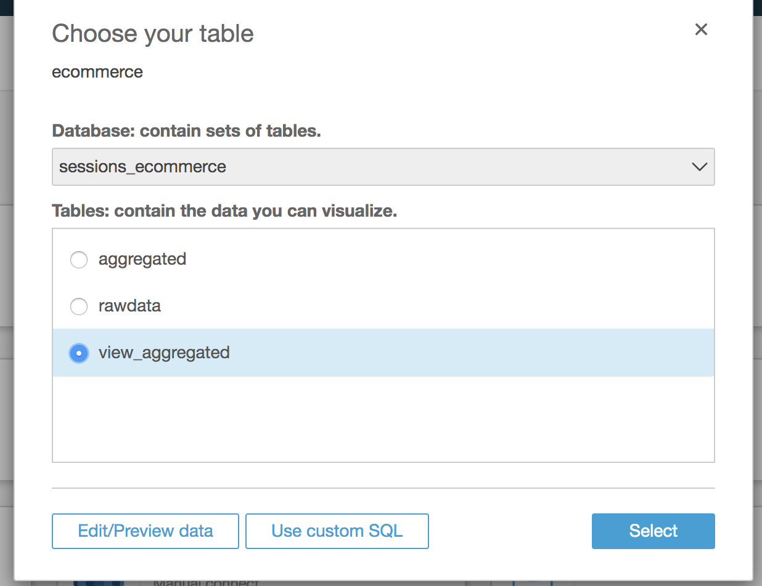

Pick the aggregated data.

Import into Spice

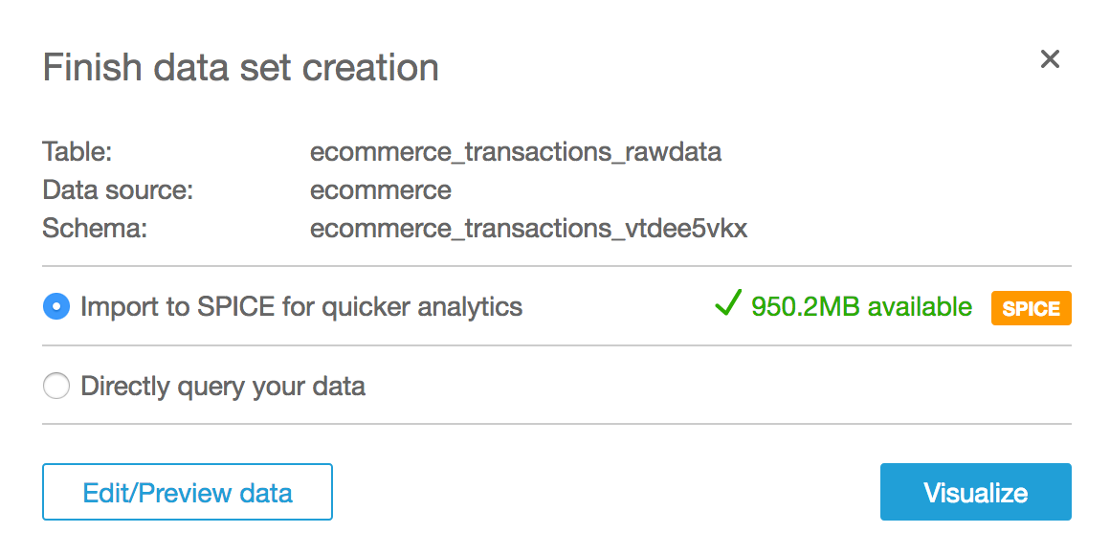

Then Visualize .

It will load the

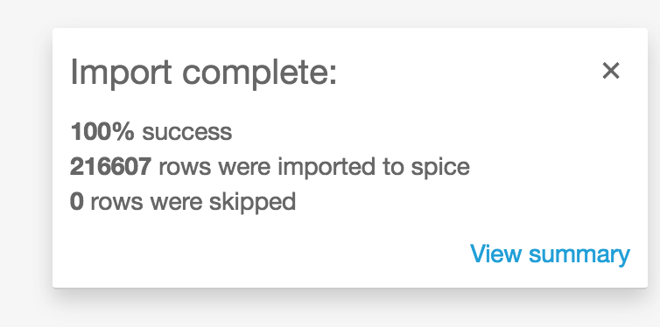

Click on Devide Field

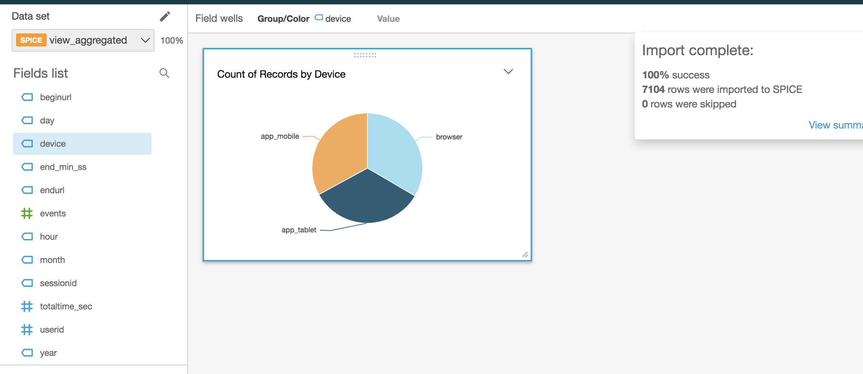

Click Add to Add a new visualization

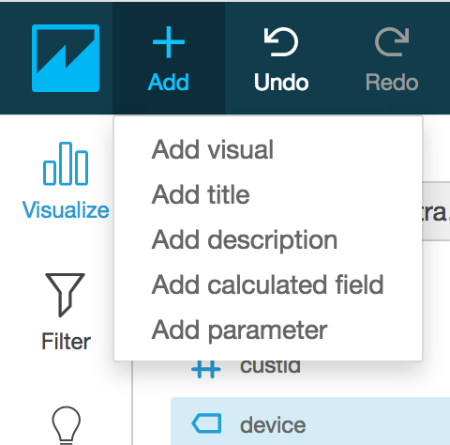

Choose the Heat Map graph type

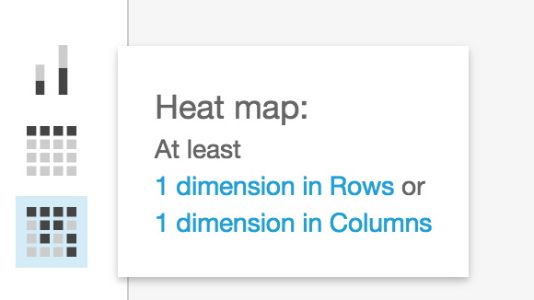

Choose first dimension begin_url

Second dimension end_url

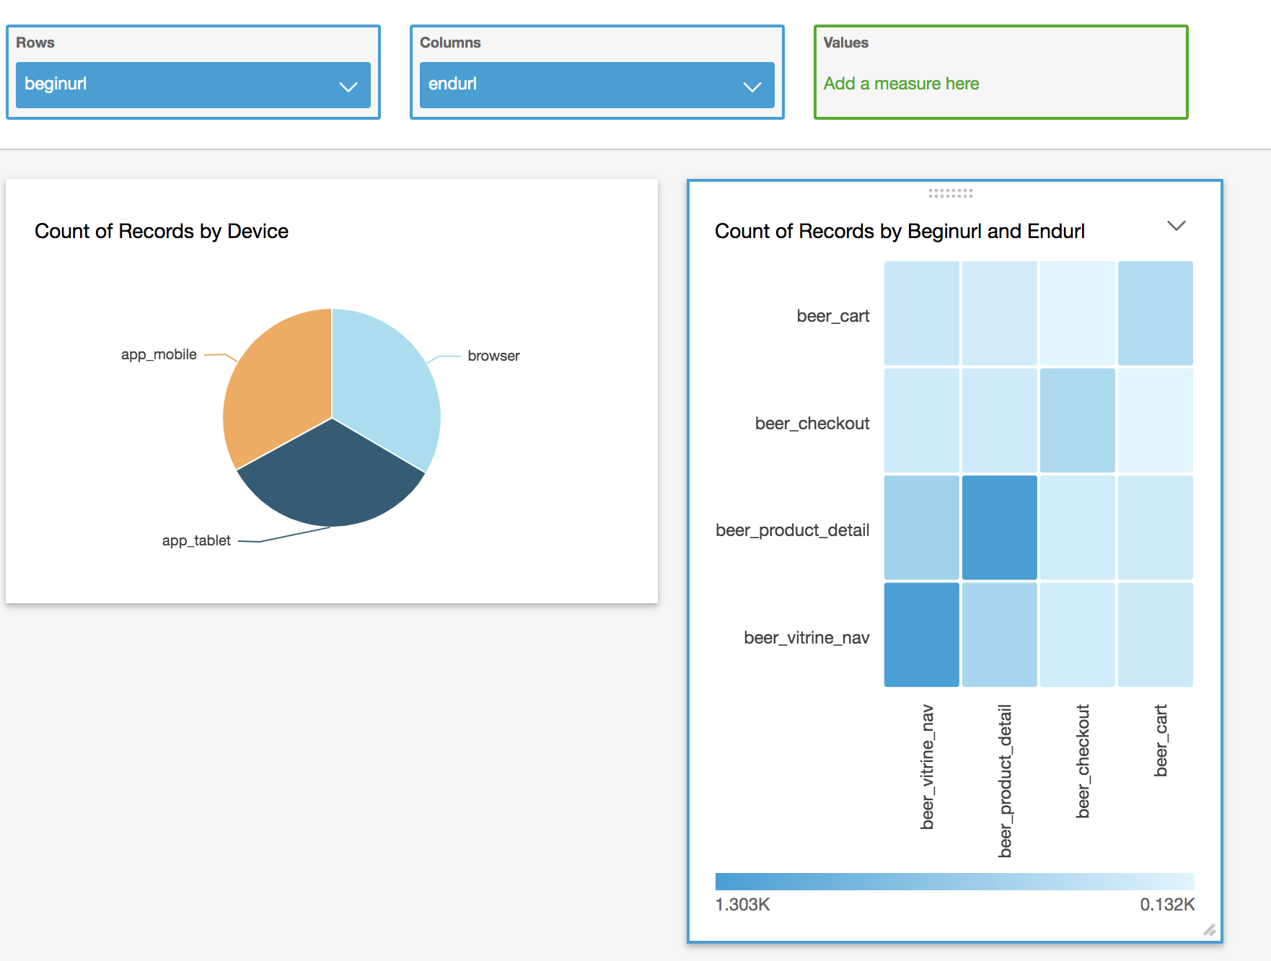

Save a Dashboard

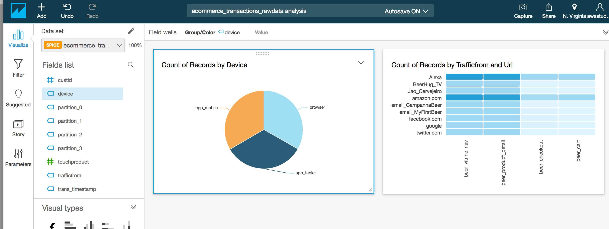

Click on Share

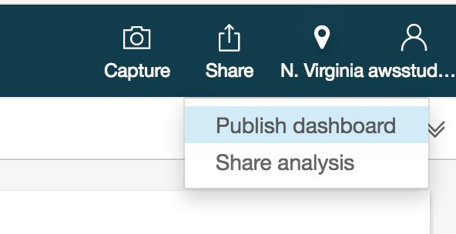

Publish Dashboard

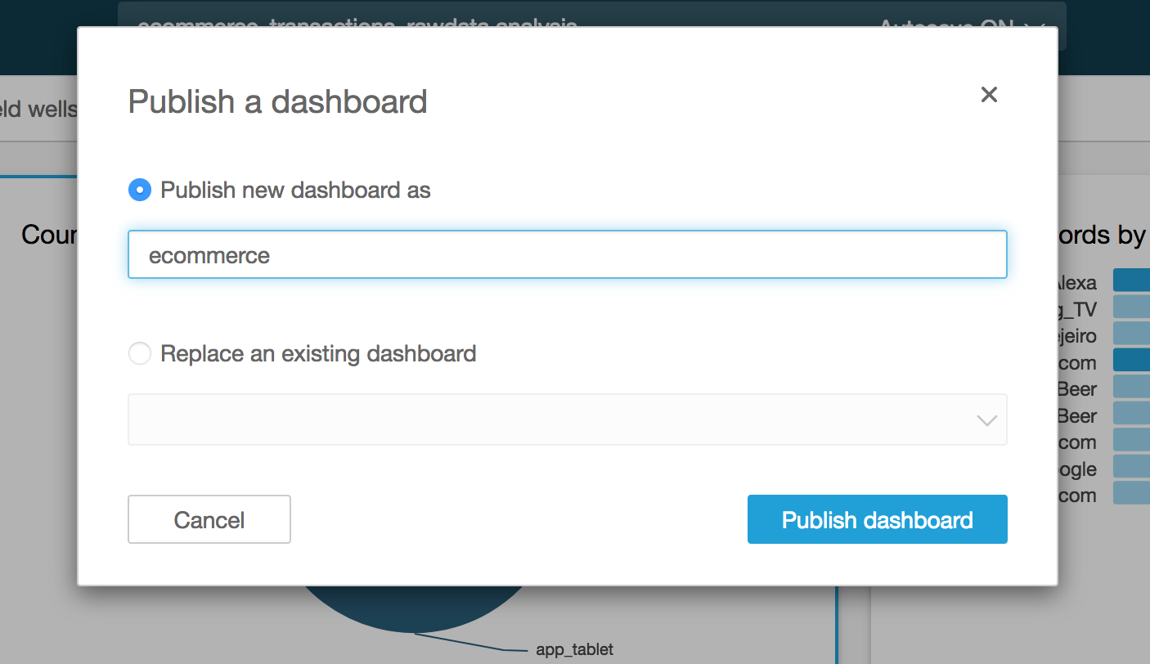

# (OPTIONAL) Tranforming Data – Amazon Glue

AWS Glue is a fully managed extract, transform, and load (ETL) service that makes it easy for customers to prepare and load their data for analytics. You can create and run an ETL job with a few clicks in the AWS Management Console. You simply point AWS Glue to your data stored on AWS, and AWS Glue discovers your data and stores the associated metadata (e.g. table definition and schema) in the AWS Glue Data Catalog. Once cataloged, your data is immediately searchable, queryable, and available for ETL. AWS Glue generates the code to execute your data transformations and data loading processes.

## Create a Tranforming Job in Glue

Go to Glue Jobs console:

<https://console.aws.amazon.com/glue/home?region=us-east-1#etl:tab=jobs>

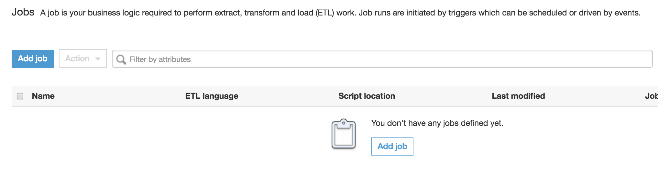

Add job

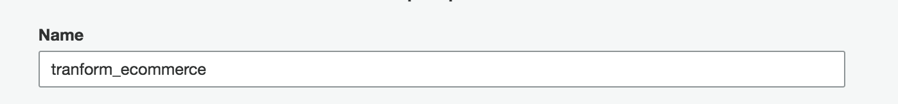

Choose ecommerce role :

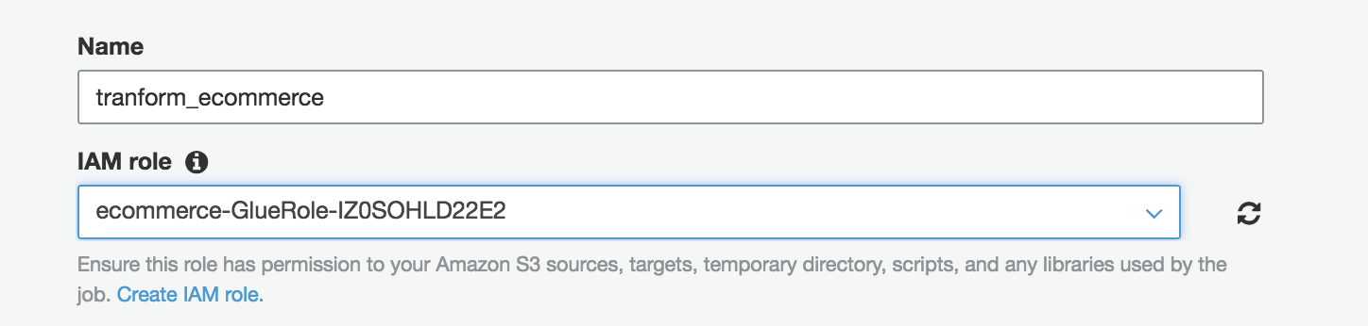

Let default and Choose between Scala or Python code

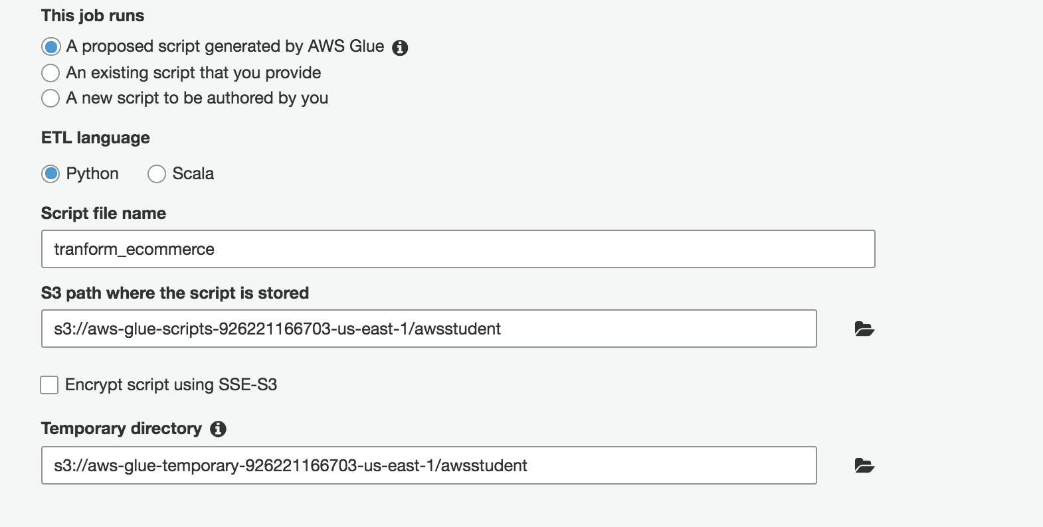

Pick the RAW table as our Source



Choose **Create Table** in your data target, Data store = **S3** , Format = **Parquet**, Target path = <<your bucket **>> /optimized**

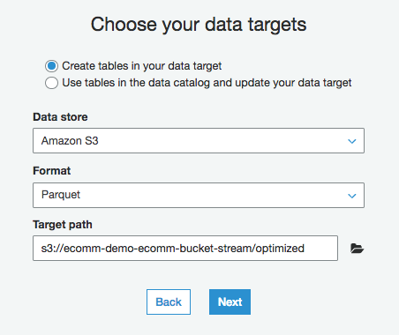

Let the Map as original

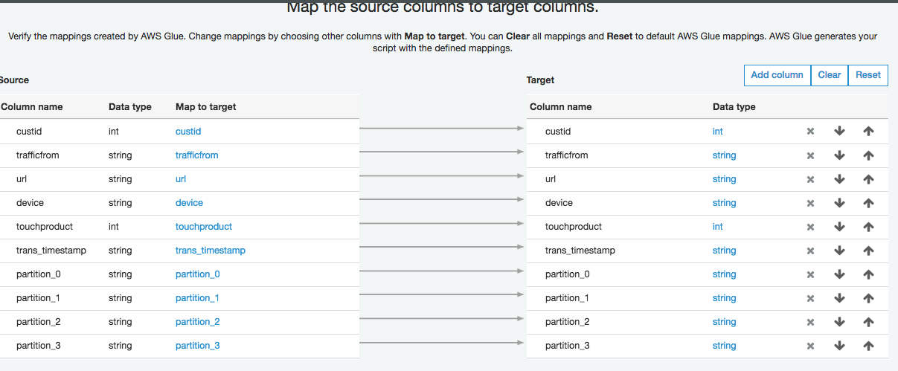

Next

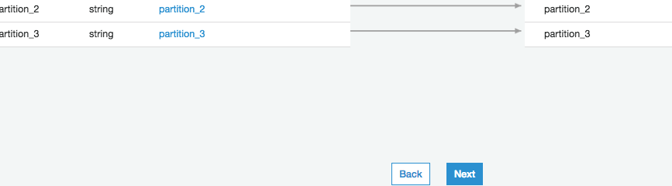

Save Job and edit script

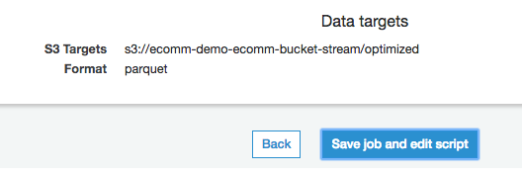

Examine the script :

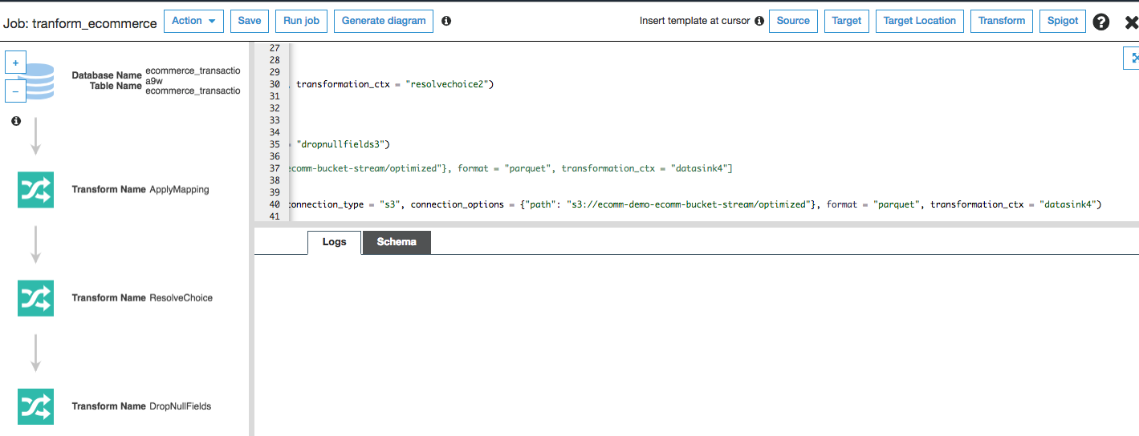

Click Run Job from the top menu

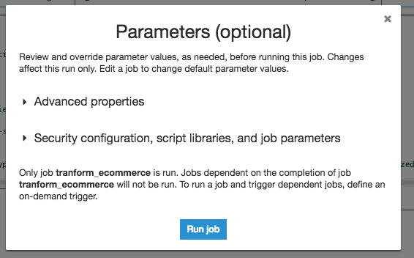

Wait for the job to complete

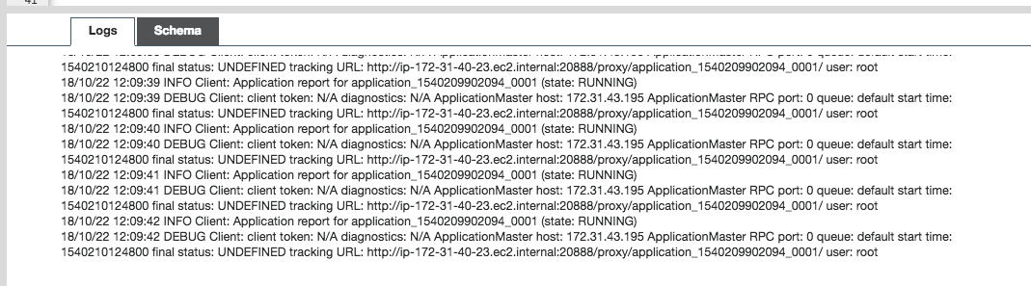

## Crawler the S3 to pick table the new table definition on Glue

<https://console.aws.amazon.com/glue/home?region=us-east-1#catalog:tab=crawlers>

Go to the Glue menu and click on Crawler, choose **ecommerce_transaction….**

Mark the job and click Run crawler.

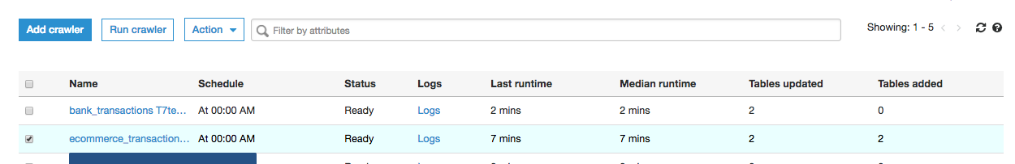

Mark the JOB and click Run crawler

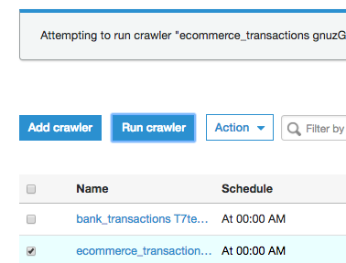

After the completion of the job you should see:



1 Table added.

## Go to Athena to query the Optimized Table you created

<https://us-east-1.console.aws.amazon.com/athena/home?region=us-east-1#query>

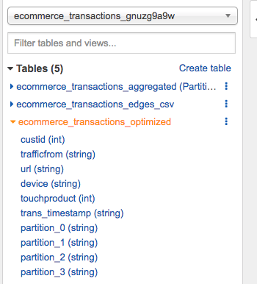

Preview the tables:

